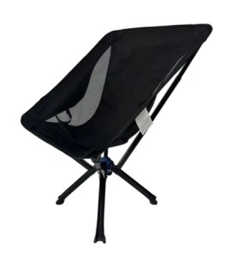
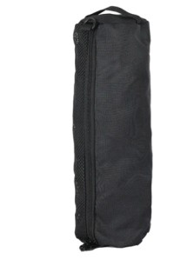
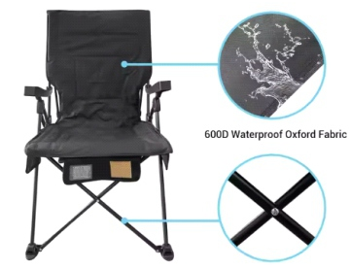
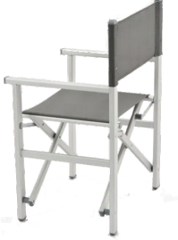
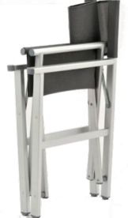
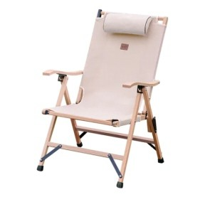
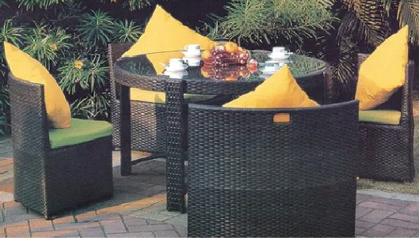
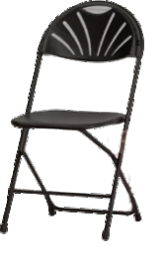
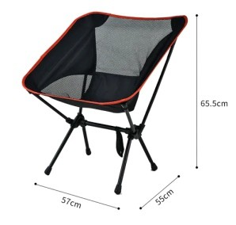
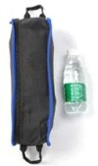
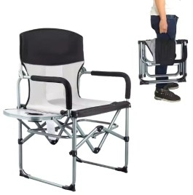
Convenient Foldable Camping Chair
JY-01
Weight:1.75kg Folded Size:14*12*38
Unfolded Size:55*53*68 Weight Capacity:150kg Inner Box: 13.5*13.5*39.5 Carton Size: 44*41.5*30
Steel Folding Beach Chair
JY-02
Product Name Folding Camping Chair Material Oxford cloth + iron pipe Single package size: 100X43X23 cm Single gross weight: 13.900 kg
JY-03
Material Metal, Steel Tube, Polyster Fabric Size 55X46X45/88CM
Outdoor Furniture, Patio, Garden, Deck It Can Be Folded,
Save Space And Easy To Carry
JY-04
Chair Size(cm) H87cm, D69cm, W58cm Material beech/pine wood,
oxford 600D with PU Weight capacity 140kgs
Package 1pc/Opp bag, 1pc/CTN or 5pcs/ CTN Package 60*60*20/4pcs, G.W.: 15kgs
Folding Camping Kermit Chair
Beach Picnic Adjustable Chair

JY-05
Muslim Prayer chair
Function Outdoor Wedding Folding Chair Advantage Hotel Wedding Retal Chair Packing 6pcs each carton
Selling Units: Single item
Single package size: 45X44X25 cm Single gross weight: 19.500 kg

JY-06
Backrest Camping Portable Chair
Oxford 900d+ Mesh, Aluminum 53*57*64 cm;41*80*88 cm (Large Size ) Load Capacity：120 kgWeight1.5-2kg Package:1pcs/Bag ;
58*41*32cm/12pcs; 37*41*35 cm/10pcs(L Size )

Outdoor Garden Arm chair

JY-07
Main Material alum+wicker Cushion with seat and back cushion Capacity 1.48CBM/set

JY-08
BBQ Camping Picnic chair
Specific Use Garden Chair Metal Type Steel
Fabric oxford
name camping chair
Size 19.6"D x 30.7"W x 32"H
Weight 5.78 Kilograms

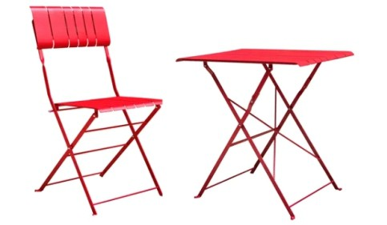
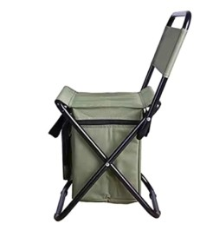
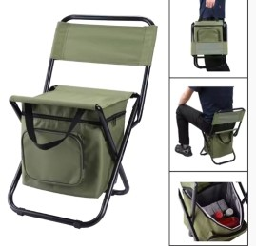
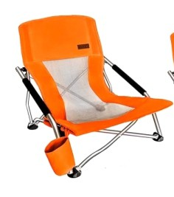
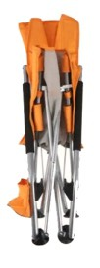
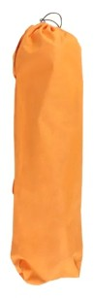
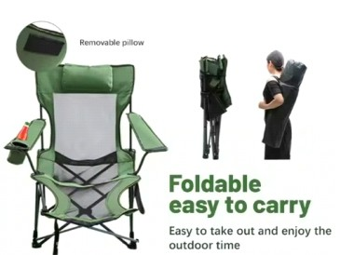
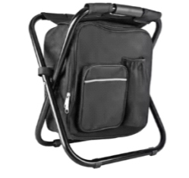
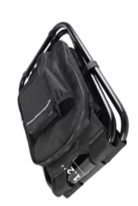
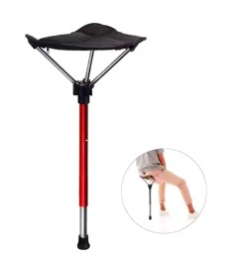
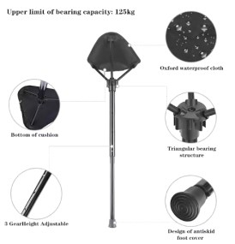
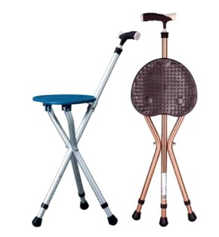
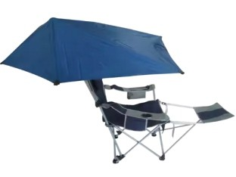
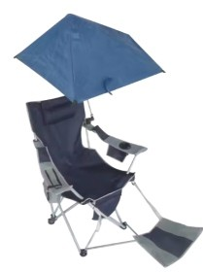
folding chair for event folding table

Luxury Arm Fishing Chairs

JY-09
Table size:71*52*71cm frame in flat steel 5X20MM slats thickness 1.8MM Chair size:43*49*86cm frame in flat steel 5X20MM slats thickness 1.8MM Package1 Set/CTN
Packing size 54*22*105

JY-10
MaterialOxford Fabric + Steel Tube Size32*31*58cm
Packaging Details1. PE bag PVC bag, Nonwoven PVC bag; Brown box, Color box
Single package size:37X12X48 cm Single gross weight:2.000 k

JY-11
Folding Beach Set
Expansion size52*53*60CM Weight3.5KG
PackingCarry bag /pcs Size75*15*20CM Fabricford cloth
LogoAccept Customized Logo

JY-12
Backpack Folding Beach Chair Material600D Oxford cloth + iron frame
LogoAccept Customized Logo Weight capacity120-150Kgs Single package size:17X17X90 cm Single gross weight:3.800 kg

JY-13
Applicationbeach, swimming,pool beach volleyball,aqua sport Featuresoft,breathable,multipurpose
portable folding stool chairs
StyleFashion chairs,beach chairs,park chairs Single package size:35X15X2 cm
Single gross weight:0.100 kg

JY-14
Foldable Travel Chair
Material7075 aviation aluminum
Tube Size13/15/16/18/19/22/25/28MM to meet all your need
Packing1 pc per carrybag, 30pcs/carton Fabric900D Oxford,High quality&comfortable Selling Units:Single item
Single package size:47X43X36 cm Single gross weight:0.500 kg

JY-15
Lightweight Folding Chair
Size400*520*670-760mm
Product NameFoldable stool and crutch MaterialAluminum Alloy(support custom) ColorRed(support custom)
Weight Capacity180kg

JY-16
The parameters of multifunction folding chair
Fabricpolyester canvas Size53/100*66*58cm Weight3.3kg
Weight capacity120kg Packing size24*22*102 cm
Single package size:19X14X95 cm Single gross weight:3.600 kg

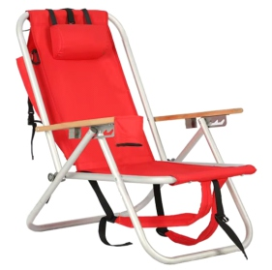
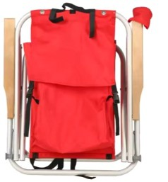
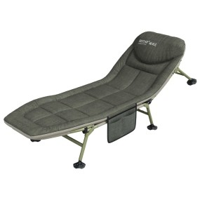
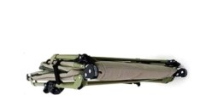
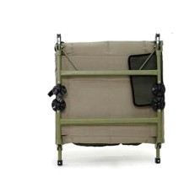
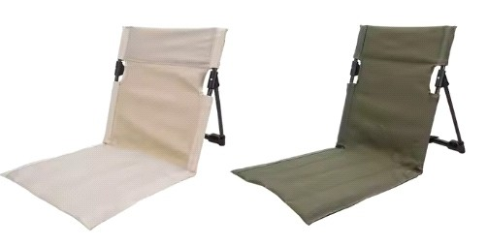
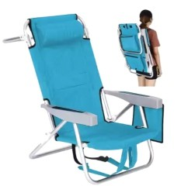
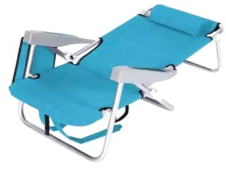
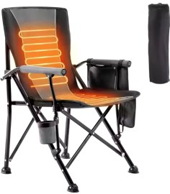
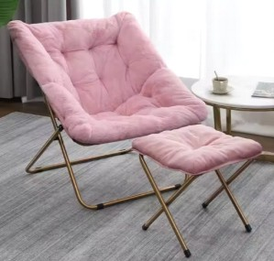
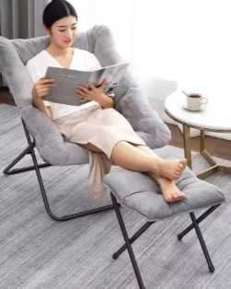
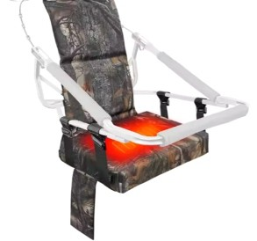
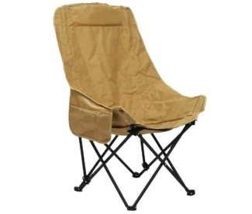
Lightweight Beach Chair

Folding Camp Chair

JY-17
Material:Metal/Fabric Fabric:600D polyester Metal:Power-coated Aluminum Frame and Solid wood arm Open size:30.33"*22.25"*29.5" Closed size:3.25"*22.25"*26.00" Tube size:0.9*24mm
Seat height:11"
Item weight:8 pounds Weight capacity:250lbs

JY-18
Size190x61cm Weight loading180KG Packing1pc/carton
MattressOxford+EPE cotton FrameStainless Steel
Single package size:95X70X17 cm Single gross weight:8.000 kg

JY-19
Custom Camping Chair
Open Size78*38*39 cm Load Capaicty150KGS Tube Diameter:22 MM
Fabric600D Polyester Oxford

JY-20
Adjustable Folding Chair
Size62*78*104cm Weight3.4kg SampleAvaliable
Material600D Oxford and Aluminum tube Single package size:80X65X15 cm
Single gross weight:4.000 kg

JY-21
Packing1pcs/carrybag, 2pcs/ctn Packaging Details1pc/carrybag, 1pcs/ctn Single package size:100X18X18 cm Single gross weight:6.000 kg
Heated Folding Chair

JY-22
Metal Frame Chair
MaterialCarbon steel + memory cotton CushionSoft Cushion Package71*11*89cm
Unit Weight11KG
Single package size:94X76X16 cm Single gross weight:15.000 kg

JY-23
Outdoor Fishing Heated Chair
Material600D oxford FeatureHEATED, Waterproof
Technicswoven，Size46*31*59cm Weight0.79kg、Selling Units:Single item Single package size:48X32X16 cm Single gross weight:1.000 kg

JY-24
Foldable Moon Chair
FeatureEasy-carrying ColorCustomized Color
Single package size:93X15X15 cm

Foldable Moon Chair

JY-25
FeatureFoldable,Portable UsageCamping,Outdoor,Fishing,Beach ColorGrey/Grey and Orange Size56x56x90CM
Single package size:109X21X31 cm Single gross weight:5.500 kg

JY-29
Size95*58*40/96/125cm Frame Materialstainless steel FeatureEasy Folding/carrying FabricOxford/PVC
Travel Picnic Foldable chair
Max Carrying weight250 lb Set up TimeLess than 1 Minute Adjustion3 position reclining Pillowwith pillow

Lying and Seat Camping Chair
Portable Sturdy Chair

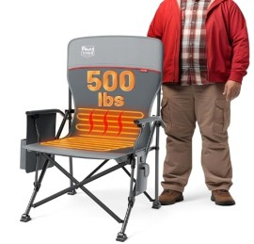
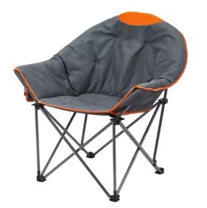
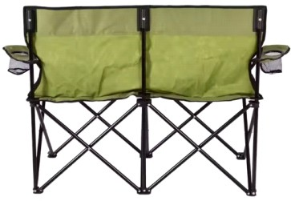
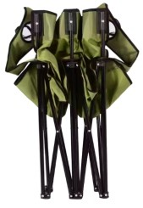
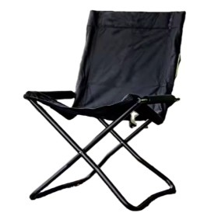
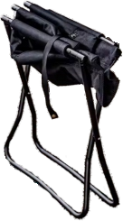
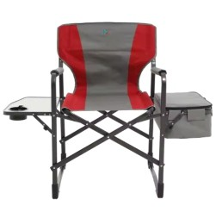
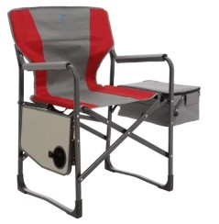
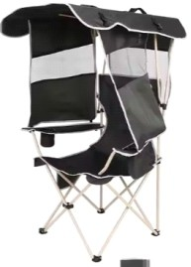
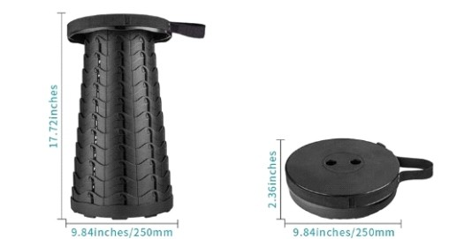
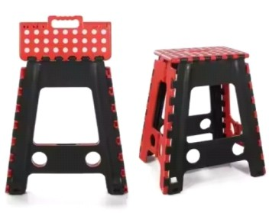
JY-26
Fabric600D Oxford Tube16mm Steel FrameSteel Frame
Single package size:80X20X10 cm Single gross weight:4.000 kg

JY-27
Fishing Office Strong Durable Chair
MaterialAluminum
unfolded sizeW60 x D63 x H83 cm folding sizeW14 x D58 x H73 cm General UseOutdoor Furniture Packaging and delivery
Packaging Details1PCS/CTN of folding chair

JY-28
With Cup Holder And
Carrying Bag Outdoor Folding Chair
PackingCarton UseOutdoor Furniture Weight17KG
Packing Size54X44X95 ColorCustomer's Request

JY-30
Product Dimensions9.84"D x 9.84"W x 17.72"H ColorBlack
BrandBoreeman StyleCollapsible & Portable Furniture FinishBlack 9.84inches/250mm

JY-31
Custom Heated Folding Chair
Product Dimensions19"D x 24"W x 40"H 3 Heating Levels
Power Bank Adaption Item Weight
Package Dimension
40 1/8"x24 3/8"x19 11/16'
500lbs 104°F-131°F

5V/2.4A
16.85lbs
42 1/2"*10 5/8"*10 5/8"

JY-32
Custom Lightweight Folding Chair
Size21*17*18cm Usageindoor Weight0.55kg MeterialPlastic PP Packaging and delivery Selling Units:Single item
Single package size:48X36X5 cm Single gross weight:2.000 kg

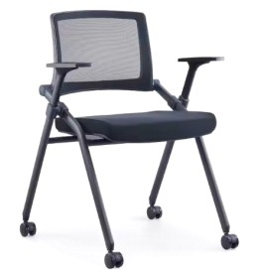
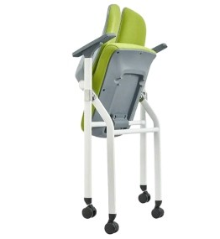
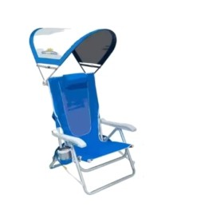
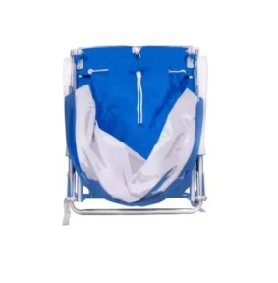
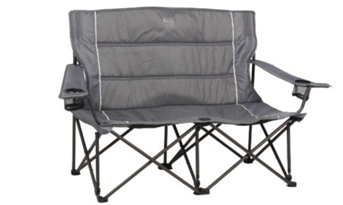
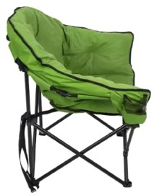
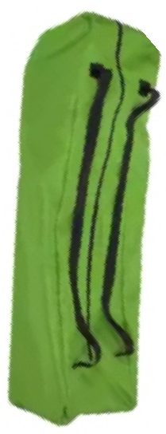
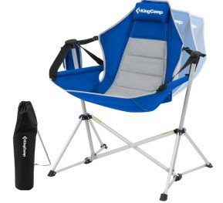
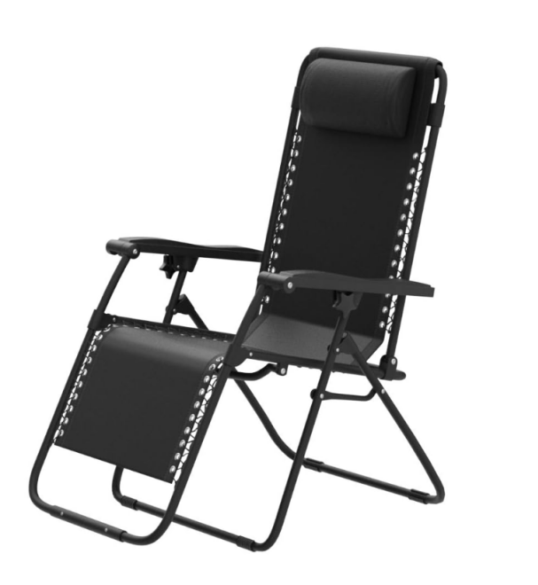
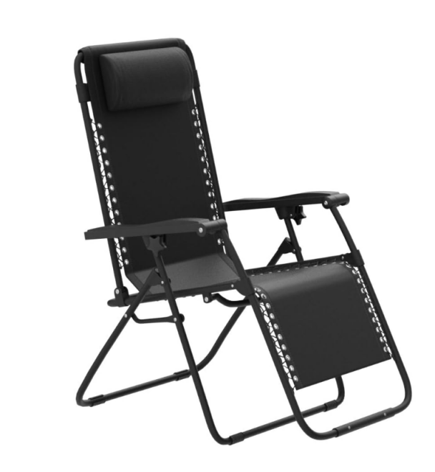
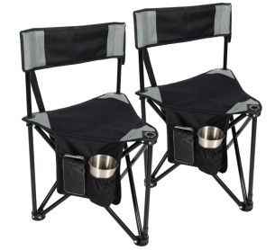
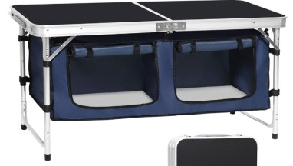
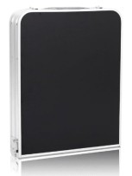
Padded Metal Folding Chair

Folding Beach Chair with Sun Shade

JY-33
FrameMetal Tube
Single package size:50X50X90 cm Single gross weight:10.000 kg

JK-34
MaterialAlloy Steel, Aluminum, Mesh PatternSolid
Product Dimensions26 x 24.2x 30.9inches Item Weight10.2 Pounds
Item Package Dimensions29.2 x 25 x 5.6 inches Package Weight5.72kg
Packaging Detailsstandard packaging Single package size:74X61.46X14.22 cm Single gross weight:4.620 kg

JY-35
Oversized Padded Folding Loveseat Chair
The camping couch's set up size is
17.72" x 41.34" x 32.28",
folding size is 11.02" x 9.45" x 32.28". Seat Depth17.7 inches
Seat Height12.8 Inches Weight Limit500 Pounds
Product Dimensions17.7"D x 41.3"W x 33.1"H Item Weight10.47 Pounds

JY-36
Oversize Lightweight Folding Sofa Chair
Fabric600D Oxford/Custom Frame MaterialMetal ColorCustomized Color LogoCustomer Logo Size61*61*95
Weight7KG
Weight capacity175KG

JY-37
Product Dimensions27.1"D x 37.8"W x 49.2"H Back StyleSolid Back
Adjustable Portable Camping Chair
Soutdoor camping chair is 37.8"x27.1"x49.2", you have roomy seat area to
wiggle around unrestricted,
and high backrest can fully support your back.
22.8" off the ground, the rocking camp chair is perfect for adults to stretch legs freely.

JY-38
Oversized Reclining Camping Chair
ColorBlack
Product Dimensions35.4"D x 26"W x 43.3"H Size26"
Back StyleSolid Back
300-pound weight capacity; upright dimensions:
35.4 x 26 x 43.3 H inch (DxWxH)

JY-39
Foldable Tripod Chair
Open size: 18" x 18" x 28"/46 x 45 x 70cm Folded size: 4" x 28"/10 x 70cm
Each weight: 3.5lbs/1.6kg
Each weight capacity: 220lbs/100kg

JY-40
Lightweight Folding Camping Table
Product Dimensions18.5"D x 47.2"W x 27.55"H Maximum Weight Recommendation66 Pounds ColorBlack
Product Care InstructionsWipe with Damp Cloth Dimensions:L47.24”*W18.5”*H27.36'';
Folded Dimensions:L23.62*W18.5*H3.96'' Hold up to 68lbs,
hook and loop fasteners and storage canvas

Portable Foldable Aluminum Camping Table
Mini Aluminum Alloy Tactical Table

JY-41
Fabricmetal namecamping table Size52"D x 21"W x 32"H
Colorblack
Shapefolding typeApplication camping/outdoor/garden Weight18.9 pounds

JY-45
MaterialAluminum ColorCustomized Color LogoAccept Customized Logo Single package size:67X45X13 cm Single gross weight:5.500 kg

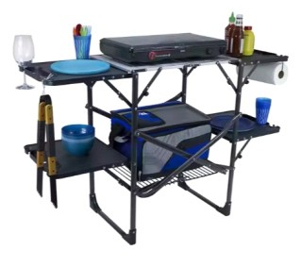
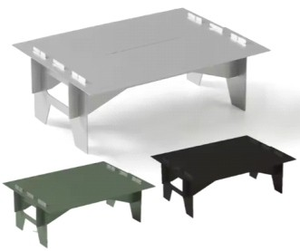
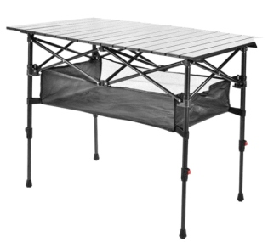
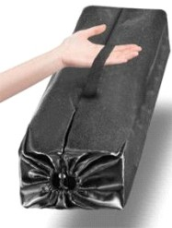
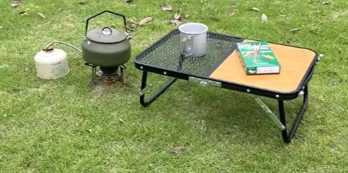
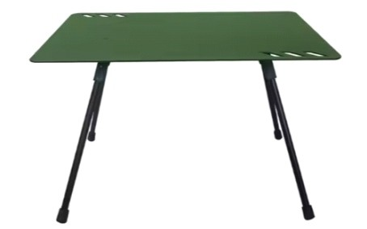
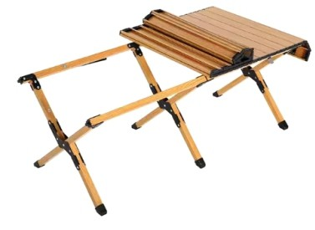
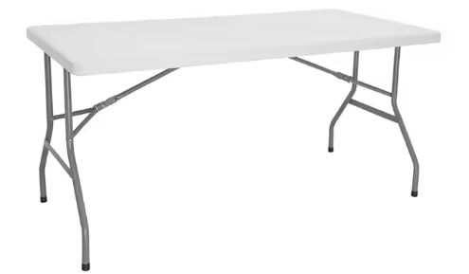
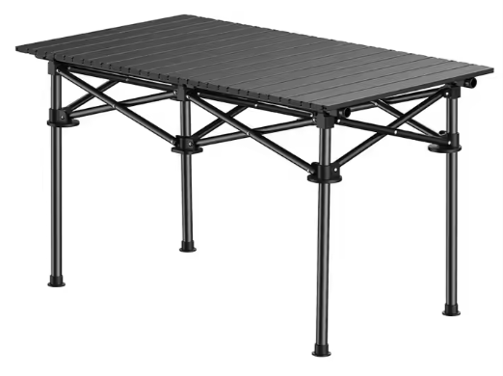
BBQ Folding Camping Table

JY-42
Metal TypeAluminum Alloy
Product NameFolding Camping Table FeatureLightweight
FunctionHiking Camping Outdoor Sports ColorLight Gray/Black/Green Size28.4*20*10cm
Weight0.27KG

JY-43
Ultralight Collapsible Camping Table
Product Name camping folding outdoor square lift dining tables
Load bearing50kg-80kg
Expand Size120cm*55cm*(55-70cm) Packing size50*50*100cm
Net weight5.52kg
Desktop materialAluminum alloy Table frame materialAlloy steel pipe

JY-44
Outdoor Stall Small table
FunctionHiking Camping Outdoor Picnic ActivityTypeOutdoor Folding Camping Tables FeatureMulti-function
LogoAccept Customized Logo Single package size:35X30X10 cm Single gross weight:1.500 kg

JY-46
MaterialAluminum Alloy Size120*60*45cm FeatureLightweight FunctionOutdoor Camping Traveling
Lightweight Multifunction Expansion Table
TypeCamping Lightweight Folding Table StyleModern Simple

JY-47
High-Quality Outdoor Camping Table
SampleAvailable MaterialPlastic
Color optionswhite, or Customized

JY-48
Foldable Metal Camping Table
Metal TypeCarbon steel MaterialCarbon Steel
Product SizeMedium: 52x51x55cm Large: 92x52x55cm
Folded SizeMedium: 55x16x13.5cm Large: 55x28x13.5cm Packing1pc/carry Bag WeightMedium: 4.10kg Large: 5.40kg

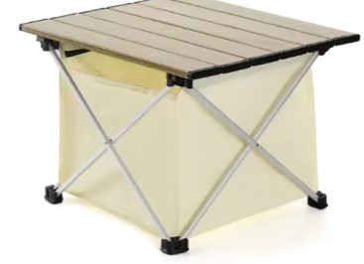
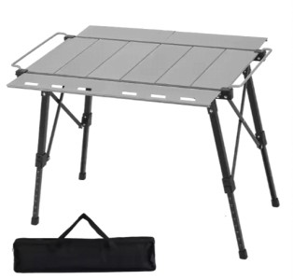
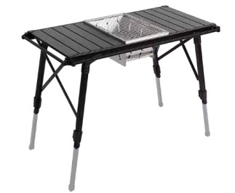
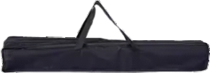
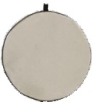
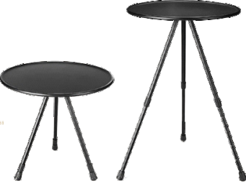
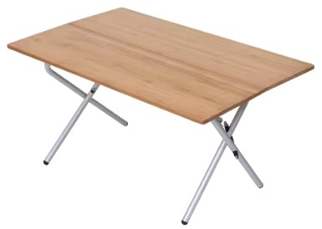
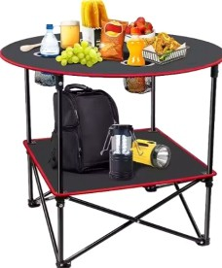
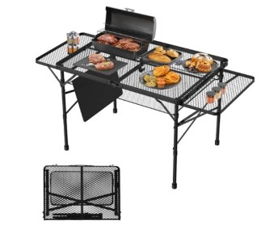
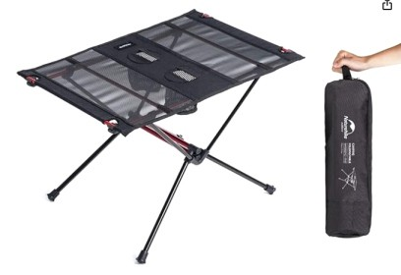
Portable picnic camping table

raised and lowered camping table with stove

JY-49
Material600D Oxford cloth Metal TypeAluminum weight(S)970g weight(M)1352g SIZE(S)40*34.5*27cm SIZE(M)56*40.5*40cm
Storage Size(S)30*28.5*21cm Storage Size(M)37.5*35*22.5cm

JY-50
Max Loading50kgs weight4.5kg
Printingsilk screen,heat transfer HS code940179000
Company ExperienceMore than 15 years Sample Time2-7days
Namepicnic table MOQ500 Pieces

JY-51
Adjustable Folding camping BBQ table
Selling Units:Single item
Single package size:65X50X15 cm Single gross weight:3.700 kg

JY-52
Detachable Aluminum Alloy Folding Camping Table
Product Size Information:Table diameter-14.5", table legs-13.8"~21",
storage bag diameter-15.2". Dimensions after all storage: 15.2" X 2". Overall weight: 2lb.
Recommended maximum weight is 20lb Product Dimensions14.5"D x 14.5"W x 21"H Maximum Weight Recommendation20 Pounds ColorBlack Desktop

JY-53
Wood StyleSolid Wood Metal TypeAluminum Selling Units:Single item
Foldable Portable Bamboo and Aluminium Table
Single package size:90X35X15 cm Single gross weight:7.000 kg

JY-54
Outdoor Dining Beach table
TypeCamping Lightweight Folding Table Size28.7"D x 28.7"W x 24.4"H
NameCustom Table Weight2.5kg

JY-55
Alloy Camping Table Outdoor Folding Desk
ColorsAs picture shows SizeCustomized PackageOpp bag, etc
ApplicationIndoor Outdoor Hotel Camping Traveling FeaturePortable

JY-56
The parameters of Ultralight Folding Beach Table Carry Bag
Product Dimensions15.75"D x 23.2"W x 15.35"H Maximum Weight Recommendation44 Pounds ColorBlack
The folding size is 16.9" x 4.5"

Portable Folding Aluminum Table
Lightweight Multifunction Folding Table

JY-57
Metal TypeAluminium FeatureEasy-carrying Weight5kg

JY-61
Product Dimensions18"D x 19.9"W x 23.8"H Maximum Weight Recommendation6E+1 Pounds ColorBlack Chrome
Item Weight：4 Pounds Frame Material:Metal
Top Material Type:Aluminum

Fishing Hiking camping table
lightweight dining table

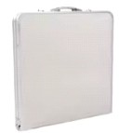
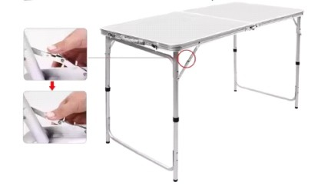
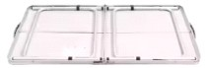
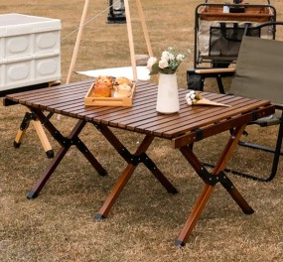
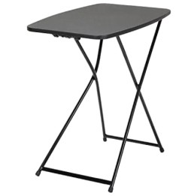
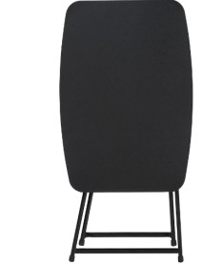
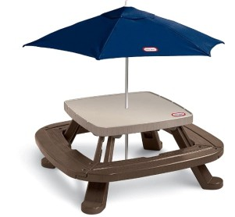
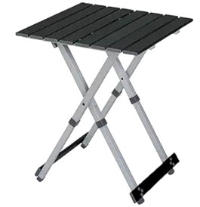
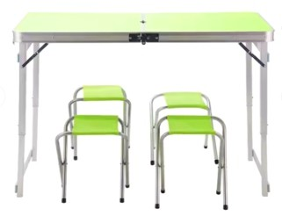
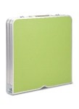
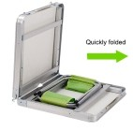
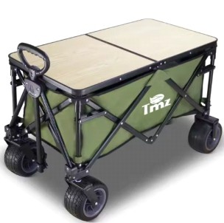
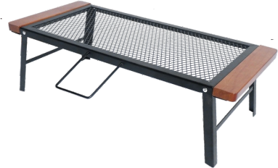
JY-58
Metal TypeAluminum Materialwood
Table Top MaterialSoild Wood Table Top ApplicationLeisure Facilities StyleSimple Modern
Size120cm x 60cm x 45cm

JY-59
Foldable Outdoor Adjustable Table
Product Dimensions18"D x 26"W x 28"H Maximum Weight Recommendation30 Pounds ColorBlack
Recommended Uses For ProductResidential Use Finish: Black
Materials: Polypropylene Table Top, Steel Frame

JY-60
The parameters of Lightweight Foldable Picnic Table
Item Weight：34.5 Pounds Style：Picnic Table Shape：Square ColorBrown
Sized to seat 6 - 8 children comfortably
Item dimensions L x W x H42.88 x 31 x 10.5 inches

JY-62
MaterialMDF board+aluminium Open size120*60*55/60/70cm Fold size60*60*10cm N.W./G.W.4.9/6.2kgs
Weight capacity100kgs Packing size63*62*11cm

JY-63
Hiking Backpacking Tables
MaterialIron,,aluminium,Medium Density Fiberboard ColorBurlywood
Single package size:45.5X47X6.5 cm Single gross weight:2.200 kg

JY-64
Foldable Iron Outdoor Camping Table
MaterialIron WeightAbout 2kg
BearingThe maximum bearing capacity is about 20kg
Size65.8*30*21cm or 65.8*30*21cm Packaging7 pieces/box

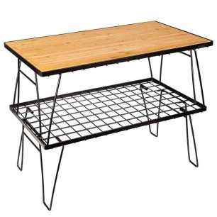
Folded Solid Wood Iron Mesh Camping Table
Folding Aluminium-Iron Outdoor Camping Table

JY-65
Framewood and steel ShapeRound TypeCamping Table

JY-69
Product nameCamping IGT Table Color,Logo,SizeCustomized
Max Loading60kgs weight4.9kg
Printingsilk screen,heat transfer

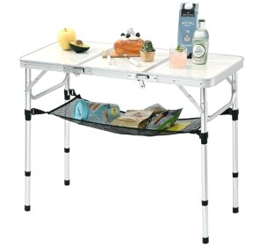
Portable Aluminum Camping Table

JY-66
Product Dimensions16"D x 35"W x 27.5"H Maximum Weight Recommendation80 Pounds ColorSilvery
dimensions of 35 inch x16 inch x 27.5 inch, and folded dimensions of
16 inch x 12 inch x 4.2 inch
Adjustable Heights: Tadjustable heights with
10.2 inch, 20.5 inch, and 27.5 inch.

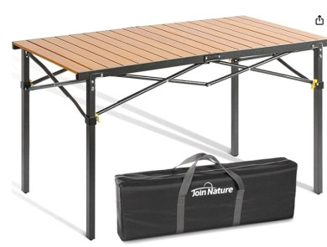
JY-67
Foldable Solid Wood Iron Camping Table
Product Dimensions27.5"D x 46.41"W x 27.5"H Maximum Weight Recommendation220 Pounds Aluminum, Wrought Iron
folded size is 30.7"L x 6.3"W x 9"H.

JY-70
Product Dimensions32"D x 16"W x 29"H Maximum Weight Recommendation500 Pounds ColorSilver
Portable Foldable Stainless Steel Camping Table
Recommended Uses For ProductDining, Cooking, Commercial use

JY-71
The parameters of Folding Iron Outdoor Table and Chairs Set
Materialsteel+Aluminium+fabric Foldedyes
Table Size150*90*70CM Chair size55x61x96cm Packing1 set/CTN
CustomizationAccept customized

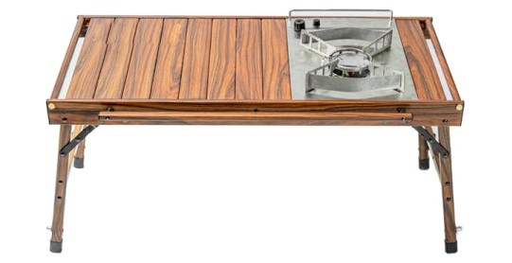
JY-68
Folding Wood Grain Outdoor Table
Weight3.6 kgs Size84*48cm height42/60cm
Table Top MaterialAluminum with wood color Leg materialAluminum black
Single package size:84X17X12 cm

JY-72
Materialaluminum alloy FeatureMulti-function Functioncamping kitchen Stylemodern
Portable Folding Aluminum-Iron Camping Table

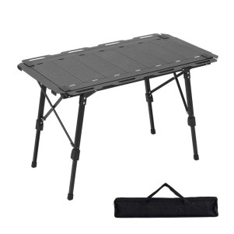
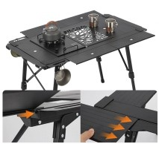
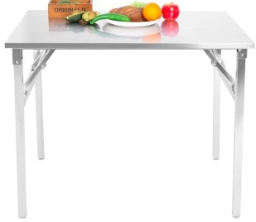
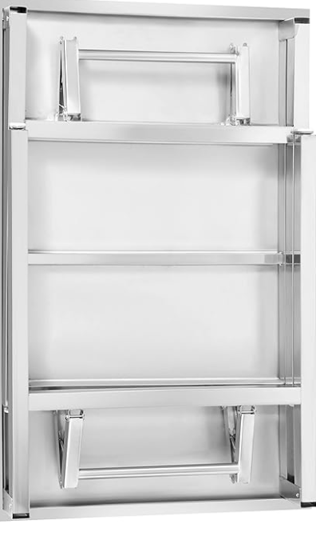
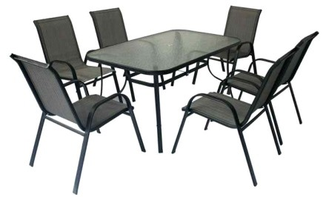
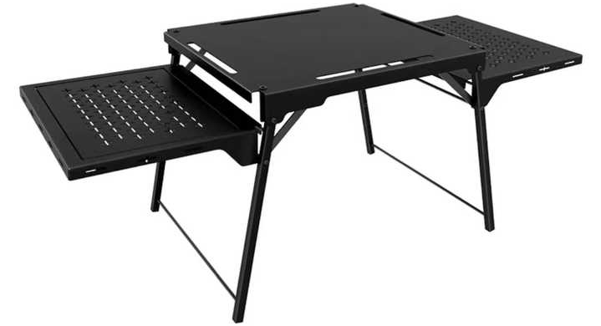

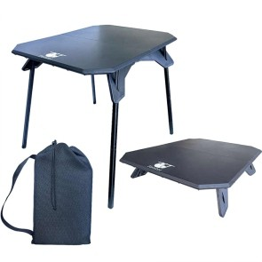
Lightweight Foldable Mini Camping Table
Commercial Steel Mesh Picnic Table

JY-73
Packaging and delivery Selling Units:Single item
Single package size:41.5X40X27 cm Single gross weight:17.000 kg

JY-77
MaterialMetal
UsageHome Holidays Gathering FeatureCombo Item
46"D x 46"W x 29.9"H

Lightweight Multifunction Folding IGT Table
Waterproof Camping Tents

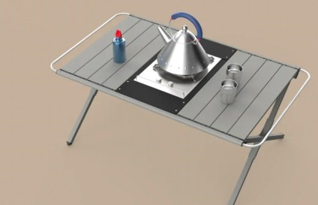
JY-74
Metal TypeAluminum MaterialAluminum ColorGray
KeywordsIGT Outdoor Folding Table Size105cm*61cm*42cm
Product WEIGHT3.3KG

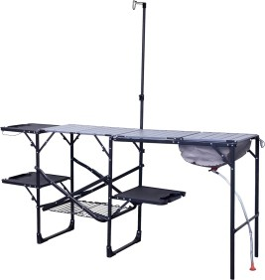
JY-75
Portable Foldable Aluminum Camping Table
ColorBlack
Open Dimensions: 56.3" L x 21.7" Wx 32.3" H;
Folded Dimensions: 34.8 " Lx 5.9" Wx 21.7" H; Table Weight: 22.4 lbs.
Item dimensions L x W x H22.2 x 70.1 x 68.3 Product Care InstructionsClean with
mild soap and water

JY-78
Area395*270*183cm FabricOxford
Outside Tent Waterproof Index2000-3000 Mm Bottom Waterproof Index2000-3000 Mm

JY-79
Family Trip Tents
Area2-3 person
FabricPolyester, Aluminum, Polyurethane, Fabric Outside Tent Waterproof Index2000-3000 Mm Bottom Waterproof Index2000-3000 Mm UsageOutdoor Camping Wild Tent MaterialPolyester
Size102.2"L x 82.7"W x 47.2"H
LogoCustomized Logo PackageStandard Carton

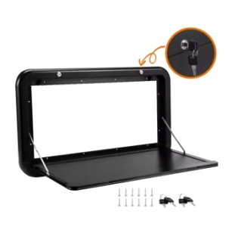
JY-76
Camping Caravan Wall-Mount Folding Table
ApplicationTravel Trailer FunctionSave Space ColorWhite&Black MaterialAluminum Alloy InstallationMounting Cables StyleModen

JY-80
Travel Shelter Tents
Outside Tent Waterproof Index<1000 mm Bottom Waterproof Index<1000 mm Building TypeConstruction Based on Need

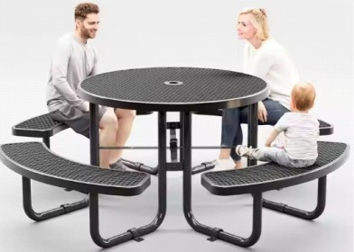
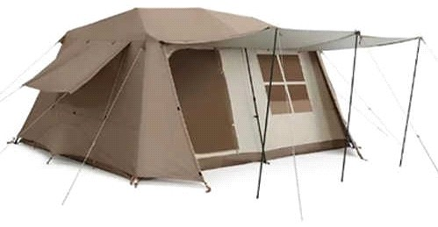
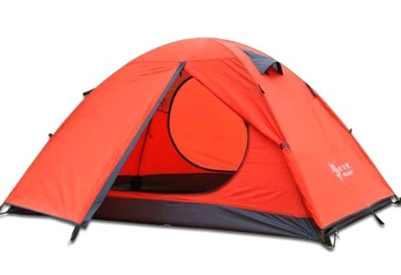
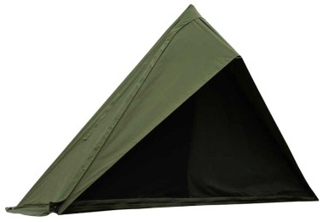

Custom Foldable 2-3 Tents

JY-81
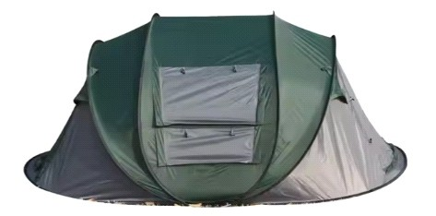
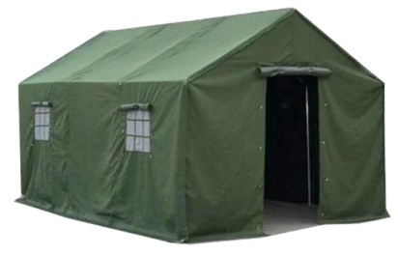
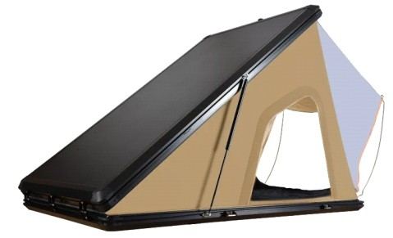
Fabric190T silver polyester
Light Weight Beach Tent
Family Camping Hiking Tent
Military Canvas Relief Tent
Outside Tent Waterproof Index1000-1500 Mm, 1500-2000 Mm, 2000-3000 Mm,
>3000 mm, <1000 mm
Bottom Waterproof Index1000-1500 Mm, 1500-2000 Mm, 2000-3000 Mm,
>3000 mm, <1000 mm
Product Size252*180*110cm Product Weight3kg
layerssingle
Type2-3 person tent Rod Materialfiberglass

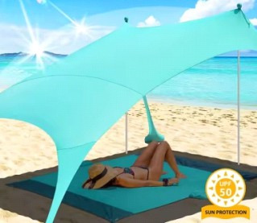
JY-82
Area210*150cm
Outside Tent Waterproof Index<1000 mm Bottom Waterproof Index1000-1500 Mm MaterialLycra fabric
ColorCustomized Color LogoAccept Customized Logo

JY-83
FabricOxford
Outside Tent Waterproof Index>3000 mm Bottom Waterproof Index>3000 mm Building TypeConstruction Based on Need Product nameDisaster Relief Tent UsageDisaster Relief
ColorBlue SizeCustomized Size MaterialOxford Fabric PoleGalvanized Steel Pipe

JY-85
Area14.7 square meter FabricPolyester
Living Room Four Seasons Tent
Outside Tent Waterproof Index1000-1500 Mm Bottom Waterproof Index2000-3000 Mm Flysheet Fabric210T Polyester
Floor Fabric210D Oxford PU2000 Size490x300x200cm
PoleTPU Tube FeatureWaterpoof

JY-86
Windproof Tactical Geodesic Base Camp Tent
Pole MaterialHot dip galvanized steel pipe Fabric Material/Tent FrameTensile membrane, Hot dip galvanized steel pipe
Cover Colorwhite/light khaki/dark khaki CraftsmanshipRepeatable disassembly design Repeatable disassembly designLevel 10
Snow Load75 kgs/sqm

JY-87
Family Camping Tent Black Coated Two Floors Two Rooms
Fabric:210D OXFORD
Outside Tent Waterproof Index:2000-3000 Mm Bottom Waterproof Index:2000-3000 Mm Building Type
Construction Based on Need OUT TENT FABRIC

210D OXFORD BLACK COATING
INNER TENT FABRIC:B3mesh+150D OXFORD SIZE:515*315*205

INNER TENT SIZE:395*275*190CM N.W:18KG
accessories:Pole * 3; Floor nail * 23; Wind rope * 9

JY-84
Material：Polyester PVC Canvas Cloth Oxford Cloth
Flexible Poles,aluminium Alloys Feature：Waterproof Placement Position
Car Roof，Specification：215*135*20cm

JY-88
Area4.84m2 FabricOxford
Ultralight Lightweight Camping Tents
Outside Tent Waterproof Index<1000 mm Bottom Waterproof Index<1000 mm Size180*180*210cm
Package size22*22*150cm Weight11kg

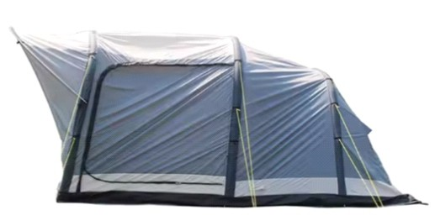
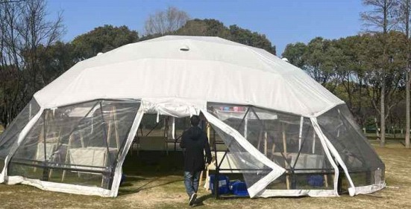
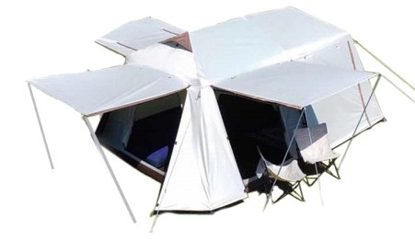
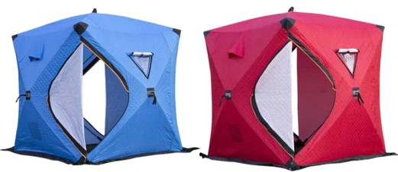

Sunshade Waterproof Large Outdoor Tents

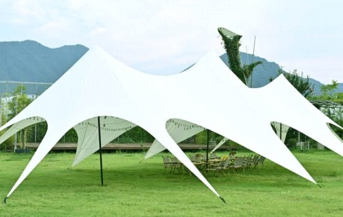
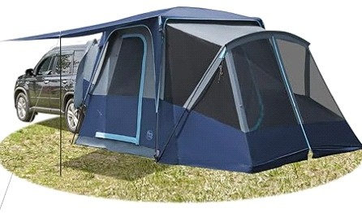
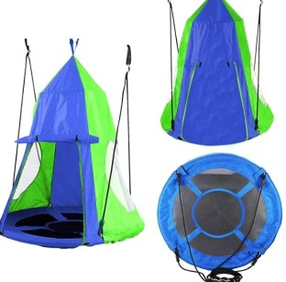
JY-89
Inflatable Outdoor Tents
Triangle Tree Tent
The parameters of Camping Family Trip Awning tent
FabricOxford
Outside Tent Waterproof Index>3000 mm Bottom Waterproof Index>3000 mm
Anti-UVUV50+
Support Pole38mm*1.5mm galvanized pipe Waterproof index of outer tent>3000mm Outer tent900D Oxford
Single package size:120X36X36 cm Single gross weight:65.000 kg

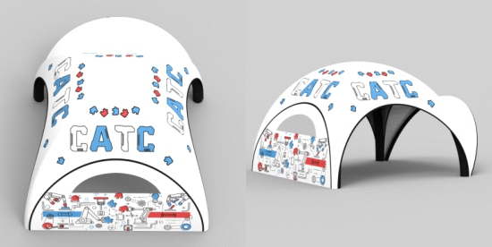
JY-90
Brand CATC Usage Event
Material PVC Tarpaulin/ TPU Bladder/ Dacron Color Customized
Feature Portable

JY-91
Product Dimensions 156"L x 120"W x 87"H Item Weight 31 Pounds
Floor Width 10 Feet Recommended Uses For Product Camping & Hiking, Car Camping Shape Rectangular

JY-93
Material: 300D Oxford Fabric & B3 Gauze Netting
rainproof pergola Camping canopy tent
Size: 12 ft x 12 ft / 3.66 m x 3.66 m Maximum Coverage: 8 people Max. Height: 90" / 2.29 m
Width for every side: 71" / 1.8 m Weight: 35 lbs / 16 kg

JY-94
Camping Soft Car Rooftop Tent
Area125cm*215cm*105cm(W*L*H) Fabric280D Oxford Canvas
Outside Tent Waterproof Index>3000 mm Bottom Waterproof Index>3000 mm Mattress205cm*124cm*6cm
Size closed(W*L*H)125cm*215cm*29cm ColorGray;Army Green;OEM/ODMService Gross weight70KG
Sleeping Capacity2-3 Person
Body280G C/P Canvas PU3000MM, W/P, W/R ShellABS Hard Shell
Ladder230cm Telescopic Ladder

JY-95
outdoor automatic canvas tents
Area200*140*110cm
Fabric210D silver coated sunscreen cloth Outside Tent Waterproof Index2000-3000 Mm Bottom Waterproof Index2000-3000 Mm MaterialOxford
Weight2kg Size200*140*110cm

JY-92
40"D x 52"H 、210D
waterproof oxford cloth
tree swing measuring 40" inch diameter 900D Oxford fabric with reinforced stitching Industrial strength steel frame is
covered by EVA foam bearing capacity to 600lbs
adjustable 47inches to 63 inches

JY-96
55"L x 55"W x 86.5"H
Outdoor Camping Shower Tent
Item Weight13 Pounds Floor Width140 Centimeters Occupancy1 Person SeasonsSummer, 4 Season
Water Resistance Technology0-1500mm

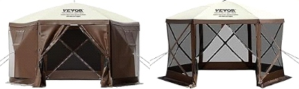
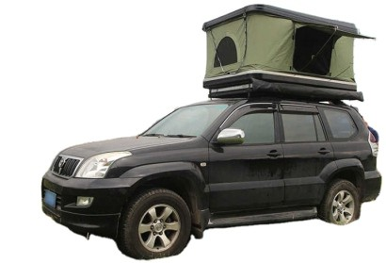
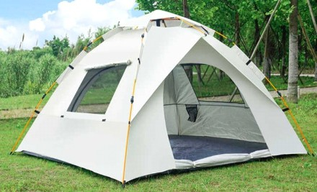
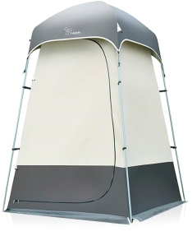

Automatic Fast Open Camping Tent
Aluminum walking cane with Led light

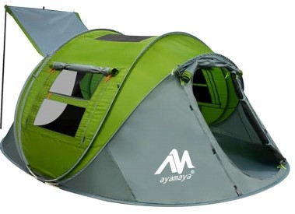
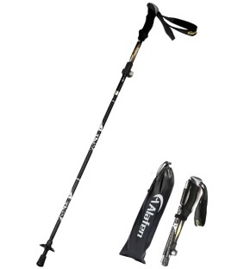
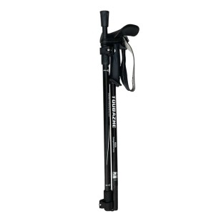
JY-97
Carbon Fiber Hiking Pole
Unique Labor-Saving Pole
Ultralight Hiking Cane
Product Dimensions118"L x 78.7"W x 47.2"H Item Weight9.9 Pounds
Occupancy4 Person Seasons4 Season
Water Resistance Technology3000mm

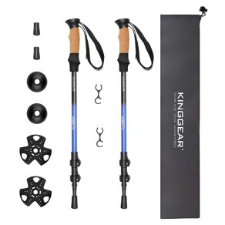
JY-98
Length (cm)135
Pipe Diameter18/16/14 mm Lock SystemQuick Lock 2.0 Pole weight260g
Adjustable Length61-135cm
Packaging Details1 pair (2 pcs)/Carrybag; 20 pairs/Carton
DIM: 69*43.5*22 cm G.W./N.W.: 16/15KG
Single package size:67X13X7 cm Single gross weight:1.030 kg

JY-99
Net weight:10.3oz/290g
Folding Size: 13.4inch/34cm; Unfold Adjustable Size: 43.3inch-49inch/110cm-125cm
Handle material: EVA foam
Shaft material: 7075 Aluminum Alloy Rod tip material: Tungsten Steel
Lock catch type: Strong ABS + Mental lock

JY-101
Material Aluminum Color Black
Shaft Material Aluminum Extended Length 37 Inches Folded Size 8 x 11.8 inches Item Weight 1.1 Kilograms

JY-102
Adjustable Telescopic Trekking Pole
Shaft MaterialAluminum Extended Length54 Inches Aircraft Grade Aluminum 7075; Tip: Tungsten Carbide;
Handle: Cork and EVA;
Carrying bag: Nylon. Product Length: 24.5 inches collapsed, 54 inches fully extended.

JY-103
Hiking Walking Sticks Hiking Pole
Shaft MaterialAluminum Extended Length 136 Centimeters Length: Please select
Material: 60% Carbon Folded Size 27 inches Item Weight 12 Ounces

JY-100
Length (cm)135
Outdoor ActivityMountain-climbing Product nameAlpenstocks
Peculiaritya standard force of 10kg~20kg FoldableYES
Weight(g)300-330
Length(cm)135-100/122-93/115-85

JY-104
MaterialAero-Grade Aluminum Alloy Steel ColorGreen 2pc
Alloy Foldable Hiking Pole
Shaft MaterialAluminum Extended Length130 Centimeters
Handle MaterialEthylene Vinyl Acetate Base MaterialAluminum
Material TypeAero-Grade Aluminum Alloy Steel850
Aero-grade 7075Aluminum alloy METAL FLIP LOCK
EVA Foam 40X12cm

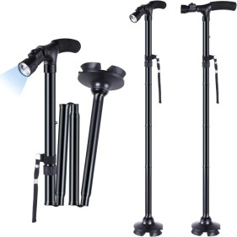
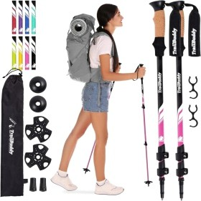
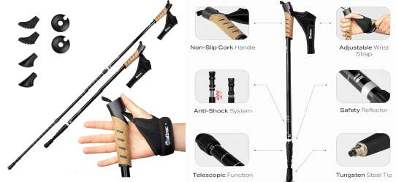
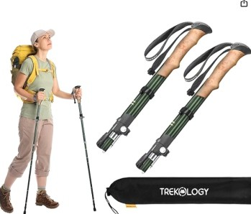

Mountain Activities Trekking Pole
hiking running pole

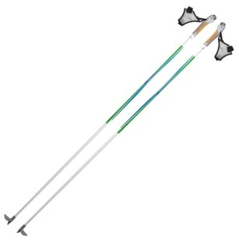
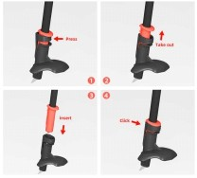
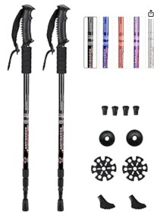
Ski Poles Snow Mountain

JY-105
Basic Information
Main Material: Aviation Aluminum Color: Black,Blue,Purple,Silver,Red Extendable Size: 25"-52"
Weight: 10.3 oz Each Pole with Tips

JY-106
Diameter16/9mm length110-175 PrintingSilk Screen printingHot Transfer TipTungsten

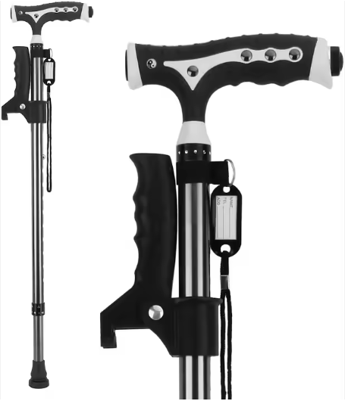
JY-107
walking Cane Activities Portable pole
Size85-97cm Handle MaterialABS
Shaft MaterialAluminum Load-bearing113kgs(250LBS) CertificatesMDD, CE, RoHS
Single package size:30.5X18X9.2 cm Single gross weight:0.420 kg

JY-109
FeatureDurable UsageOutdoor Sports Weight129,134g
LogoAccept Customized Logo HandleSoft EVA Size110,120cm

JY-110
foldable telescopic walking cane
Handle MaterialRubber Base MaterialRubber Material TypeAluminum Measurements
Folded Size13.7"
Item Dimensions W x H5.12"W x 38"H Item Weight1 Pounds

JY-111
Old Man Walking Sticks
Shaft MaterialAluminum CANE SEAT * 1 STORAGE BAG * 1 EXTRA TRIANGLE TIP * 1
Product Information Weighs 1.6 pounds
Length 34 inches
Minimum size of 20.8 inches Hold up to 396 pounds

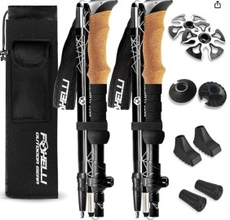
JY-108
Collapsible Walking Trekking Pole
MaterialAluminum ColorBlack
Shaft MaterialAluminum Extended Length14.6 Inches Aircraft grade 7075 Aluminum
11.6 oz (329 g)
39"-47"(100-120 cm)
14.6"(37 cm)
Natural Cork and EVA

JY-112
Length (cm)92 Outdoor ActivityHiking
Alloy Telescopic Walking Pole
Telescopic length70-92cm Packing40pcs/carton ColorGolden

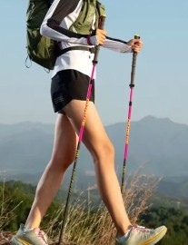
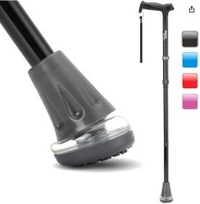
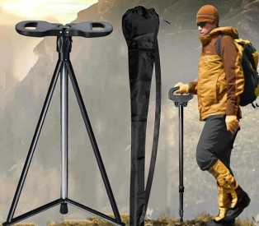
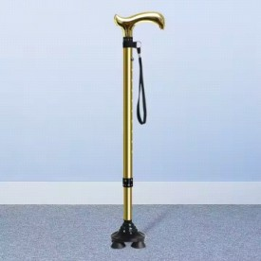

Collapsible Nordic Hiking Pole
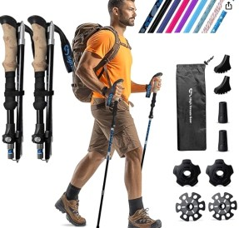

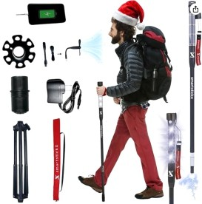
Led Light Trekking Pole

JY-113
Extended Length135 Inches Handle MaterialCork
Base MaterialRubber Shaft MaterialAluminum Material TypeAluminum Measurements
Item Weight0.9 Kilograms Extended Length135 Inches

JY-114
Extended Length45 Inches
Tactical hiking stick can easily power up your smartphone or any other USB device using the convenient USB Port.
Two modes available on LED:
a bright white light perfect

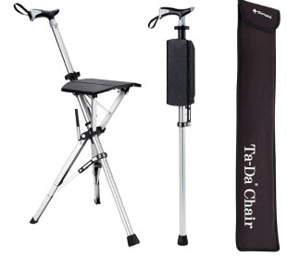
JY-115
old men alpenstock trekking cane
Shaft MaterialAluminum Extended Length32.2 Inches
Maximum Load Capacity 242lbs (110kgs) Fatigue Test up to 12,500 Times
At 920g, Equivalent to a Water-Filled Thermos Item Dimensions W x H3.74"W x 32.28"H Item Weight2.03 Pounds
Extended Length32.2 Inches

JY-117
MaterialLightweight Aircraft Grade 7075 Aluminium with Tungsten Steel Tips and Removable Rubber Feet
Double Handle Folding Trekking Pole
ColorBlack
Shaft MaterialAluminum Extended Length135 Centimeters
LONGER SIZE (for those 5'7" up to 6'2") expanded poles adjust from 115 cm to 135 cm (45.25" to 53")

JY-118
Old Man Medical Cane
Stick TipRubber Tip LogoCustomize Logo Acceptable SizeOne size adjustable PackingOpp Bag

JY-119
Carbon Silk Print Ski Pole
Item Package Dimensions L x W x H45 x 2 x 1 inches
Package Weight0.48 Kilograms
Item Dimensions LxWxH45 x 5 x 5 inches Item Weight15.73 Ounces

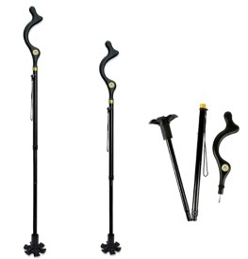
JY-116
Outdoor Climbing Equipment Hiking Pole
Shaft MaterialAluminum Extended Length49 Inches
10 Adjustable heights from 40 up to 49 inches, easy folding and can be used for anyone from
4.5 feet up to 6.5' feet and up to 300 pounds.

JY-120
Length (cm)135
Lightweight Ski Pole
MaterialAlu 6061/Alu 7075/Carbon Dia.16mm
Length100-135cm PackingPolybag
Single package size:105X2.3X1.8 cm Single gross weight:1.000 kg

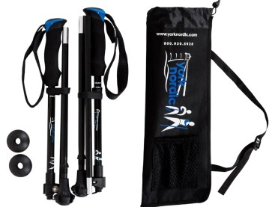
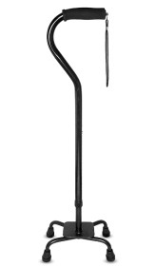
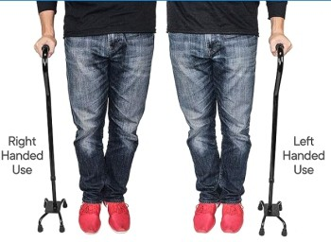
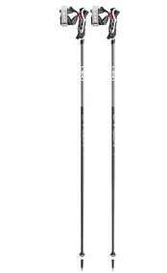
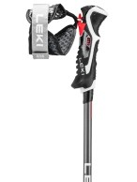
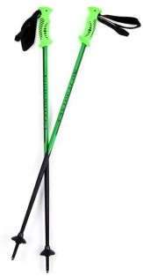
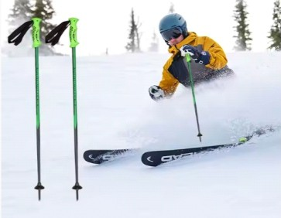

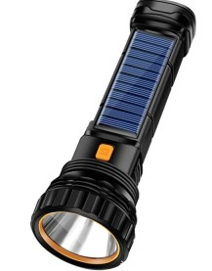
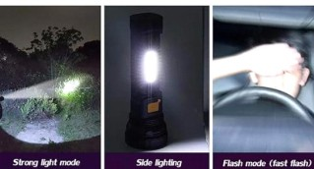
outdoor multi-function portable lamp

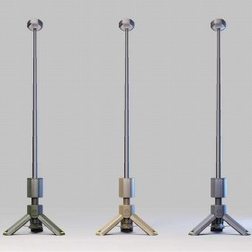
rechargeable camping lanterns

JY-121
Product Dimensions : 6.88 x 2.28 x 2.28 inches;
4.97 ounces
Water Resistance LevelWaterproof Brightness1000 Lumen
Supported Battery TypesLED Voltage5 Volts (DC)
Light Path Distance2600 Feet
Number of Batteries1 AAA batteries required. Additional Featuresportable
Power SourceSolar,Battery Powered Light Source TypeLED

JY-122
Certificationce, rohs, PSE, FCC Working Temperature(℃)-10℃~50℃ Battery Capacity3.6V/3350mAh*3 Power5W
Charging timeAbout 5.5 hours Single package size:26.3X5.6X5.6 cm Single gross weight:0.850 kg

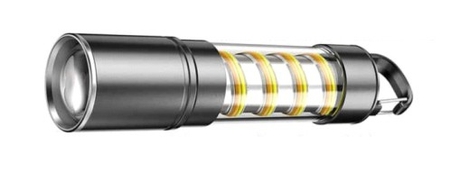
JY-123
Portable Emergency Flashlight Torch
Lighting Period (h)>12 Warranty(Year)1-Year LED Light Source10W LED
FunctionHigh-Medium-Low Battery18650 Battery Brightness1200 Lumens Size175*36mm
Single package size:15X4X3 cm Single gross weight:0.270 kg

JY-125
UseCamping Light SourceLED
USB rechargeable camping light
Color Temperature(CCT)6885 Input Voltage(V)5V/1A
Lamp Luminous Efficiency(lm/w)518 Support DimmerYes
Bulb TypeLED Warranty(Year)Other Handle360 rotation Packaging and delivery Selling Units:Single item
Single package size:17.5X16.5X22.5 cm Single gross weight:0.920 kg

JY-126
Portable USB Camp Light
Beam Angle(°)360
Lamp Luminous Efficiency(lm/w)10 Lamp Luminous Flux(lm)30-720 Working Temperature(℃)-20 - 65 Lifespan (hours)10000
Product Weight（kg）0.39 Lumen value30-720LM
Color temperature1800-7000K Charging time6H
Working time11-180H
Single package size:15.0X25.0X15.0 cm Single gross weight:1.000 kg

JY-127
Multifunctional LED Lantern
Power SourceBattery
latern typeFlashlights & Torches materialABS
Size130*35mm Weight96g
Power SupplyBuilt-in Rechargeable Battery Voltage5V,3W
Packaging and delivery Selling Units:Single item
Single package size:25X10X10 cm Single gross weight:3.000 kg

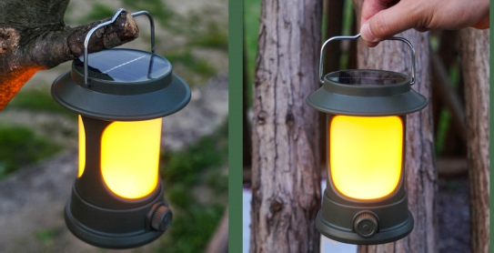
JY-124
waterproof portable led camping lamp
latern typeCamping Lanterns product nameCamping lamp materialABS+PS UsageLighting Size139*108*90mm
Single package size:25X15X15 cm Single gross weight:3.000 kg

JY-128
Lamp Body MaterialABS IP Ratingip66
High Brightness LED Camping Light
Light SourceLED Other attributes Beam Angle(°)120
Working Temperature(℃)-10 - 50 Model NumberX35
Packaging and delivery Packaging DetailsColor gift box Selling Units:Single item
Single package size:22X22X16 cm Single gross weight:0.770 kg

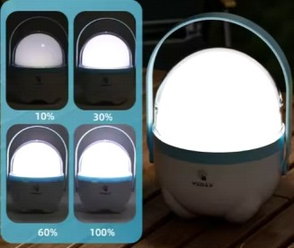
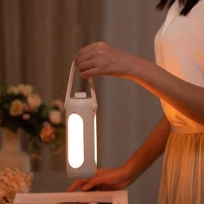
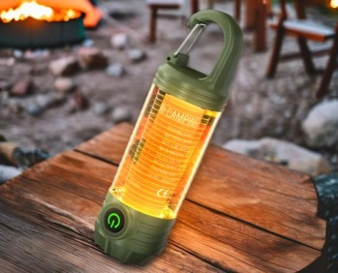
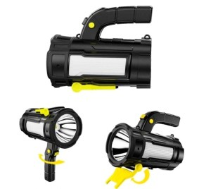

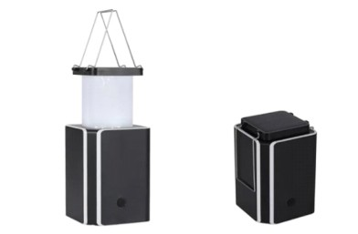
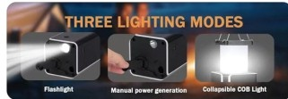
The parameters of LED Solar Camping Light

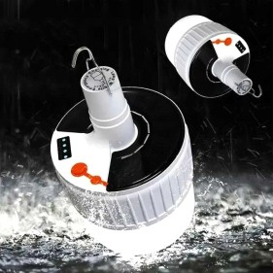
Remote Control Emergency Camping Lamp

JY-129
Light Source TypeLight Emitting Diode (LED)
4.6"L x 3.07"W x 3.15"H
Battery Life5 Hours
Water Resistance LevelWater Resistant
Light Source TypeLight Emitting Diode (LED) Power SourceSolar Powered
Supported Battery TypesLithium-Ion Voltage5 Volts
Number of Batteries1 Lithium Ion batteries required.
ColorBlack-W-4Pack
Power SourceSolar Powered
MaterialAcrylonitrile Butadiene Styrene (ABS)

JY-130
Input Voltage(V)DC 6V
Lamp Luminous Efficiency(lm/w)100 Color Rendering Index(Ra)80 MaterialABS
BatteryLithium Rechargeable Battery Power SupplyUSB powered/Solar Lighting Model5 model
Packaging and delivery Selling Units:Single item
Single package size:19X11X35 cm Single gross weight:1.400 kg

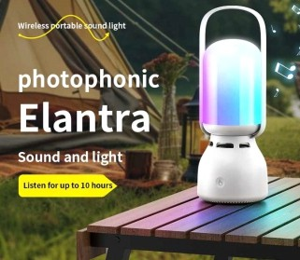
JY-131
New Design Camping Lantern
FunctionMusic Player Bluetooth version 5.1 Distance 10m
Battery 1800mah Product size 88.5x240mm
Product color white,beige LED Power 2.4W
Rate Power 5W

JY-133
Light Source TypeLight Emitting Diode (LED) Item Weight246 Grams
LED Emergency Camping Lantern
Item Dimensions L x W x H2.2"L x 2.2"W x 5.6"H Battery Life80 Hours
Water Resistance LevelWaterproof
Light Source TypeLight Emitting Diode (LED) Power Source5000mAh Battery Powered Supported Battery TypesLithium-Ion or Lithium-Ion Polymer Voltage5 Volts (DC) Wattage18.5 Watt-hours
Brightness1200 Lumen Mounting TypeTabletop Mount Light Source Wattage0.33 Watts
Number of Batteries1 A batteries required+

JY-134
Magnetic Waterproof Camping Lantern
ApplicationGarden Size100*145 mm Weight205g
Battery Capacity2000mAH MaterialAmbient light strip
Amber light strip255mm 300ma 1900-2200k Low LightingThe Max.working time 40 hours The Max.working time40 hours
Time to fully charge2-4hours

JY-135
Camping Cooker with Removable Legs
Grill Type3-5 people Metal Typealuminum alloy FinishingNot Coated
DescriptionBarbecue Grill Gas Bbq Grill AdvantageEasy Operation High Efficiency Packaging and delivery
Selling Units:Single item
Single package size:55X45X25 cm Single gross weight:3.100 kg9I9R

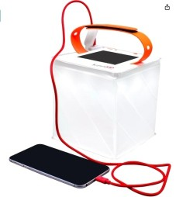
JY-132
solar emergency camping light
Light Source TypeLight Emitting Diode (LED) Item Weight10 Ounces
Item Dimensions L x W x H8.15"L x 2"W x 9.4"H Battery Life25 Hours
Water Resistance LevelWaterproof
Light Source TypeLight Emitting Diode (LED) Power SourceSolar Powered
Supported Battery Types2000mAh Voltage5 Volts
Brightness200 lumens Mounting TypeTabletop Mount ColorBright White
Power SourceSolar Powered MaterialComposite

JY-136
Warranty12-month guarantee
Mini Tourist Gas Stove
After-sale Service12-month guarantee SampleAvailable
MaterialMetal Body w/Enamel Coated Steel Drip Pan
size44X20X7CM Weight3.75kg Power2.3KW
Fuel Type8 oz Butane Canister Single package size:25X50X15 cm Single gross weight:3.750 kg

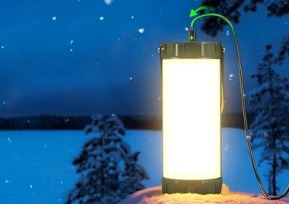
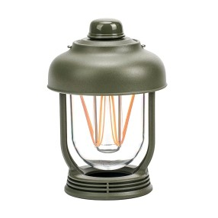
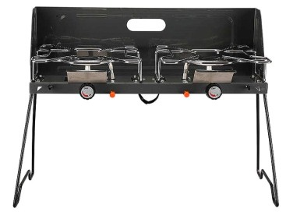
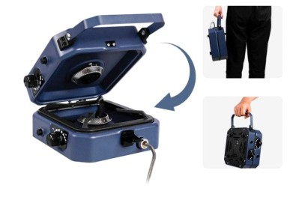

Cast Iron Combo Cookware
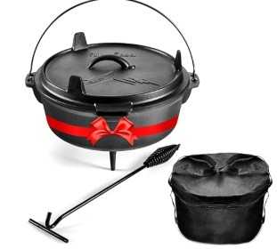

Mini Ultralight Folding Gas Stove
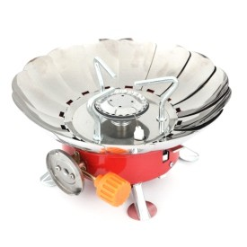

JY-137
Lid MaterialCast Iron Finish TypeNon Stick
Is the item dishwasher safe?No MaterialCast Iron
Product Care InstructionsHand Wash Only Measurements
Item Weight17 Pounds
Item Dimensions W x H14"W x 6.8"H Capacity5.7 Liters
Temperature Rating370 Degrees Celsius

JY-138
FunctionHiking Outdoor Treeking Sprot Traveling
InstallationOperat Fuel TypeGas Butane
Gas TypeButane Canister FuelLiquefied Gas
Piece Number Of Wind Deflector<5 Application MethodAutomatic Materialiron
Stove fuelButane
With Ignition Device or NotYes

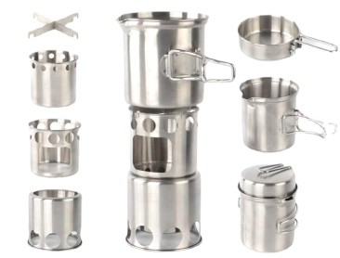
JY-139
Aluminium Camping Cook Set
Capacity<1L
Product NameCamping Wood Stove MaterialStainless Steel
UsageOutdoor Camping Hiking Travelling TypeSurvival Multifunction Tool FeatureLightweight
FunctionHiking Outdoor Treeking Sprot Traveling
Size15.5*12.4CM
ApplicationOutdoor Beach Hiking Camping Travelling
LogoAccept Customized Logo PackingCarton

JY-141
Materialmetal
Picnic Bowl Cookware Camping Cooking Set
Metal Typestainless steel Applicable StoveGas Cooker
Pot Cover TypeStainless Steel Cover Pot CoverWith Pot Cover
Capacity1-2L Brand NameOEM

JY-142
Mini Portable Outdoor Camping Oven
ColorBlack MaterialAlloy Steel
Special FeatureLightweight MaterialAlloy Steel Heating Elements1
Product Dimensions10"D x 15"W x 6.5"H Wattage650 watts
Controls TypeKnob

JY-143
Lightweight Mini Butane Gas Stove
ColorBlack Capacity<1L Power16800W
Unfold size22.5 *13cm Packing size76*25.5*58.5cm Gross weight19.5kg Packaging and delivery Selling Units:Single item
Single package size:76X25.5X58.5 cm Single gross weight:19.500 kg

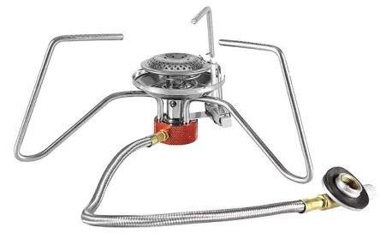
JY-140
Portable Stainless Camping Gas Stove
Capacity<1L
KeywordsSurvival Camping Tool Packaging and delivery Packaging DetailsSelling Units: Single item
Single package size: 11.5X8.5X7.5 cm
Single gross weight:
0.300 kg
Selling Units:Single item
Single package size:5.5X6.5X9.18 cm Single gross weight:2.200 kg

JY-144
Capacity10L MaterialStainless Steel Unfold Size20*20*27CM Fold Size20*5*27CM TypeCharcoal Grills Weight2.5kg
Stainless Steel Mini Cassette Stove
Single package size:24X20X20 cm Single gross weight:3.000 kg

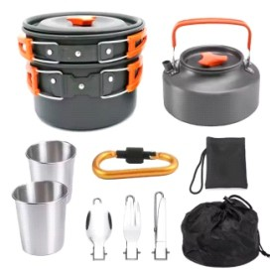
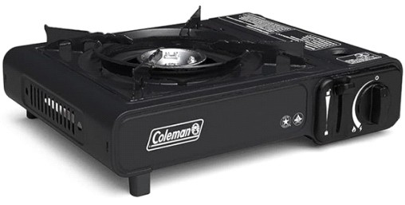
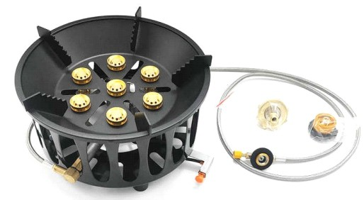
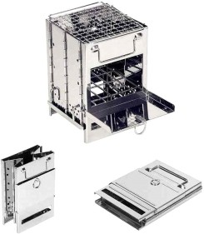

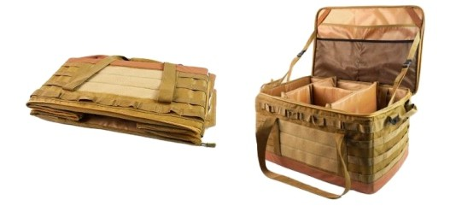
Picnic Tableware Tote Bag

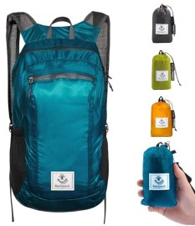
waterproof lightweight Hiking backpack

JY-145
Closure TypeOpen Have DrawbarsNO StyleFashion Size54*37*30CM Occasionoutdoor Capacity60L
Packaging and delivery Selling Units:Single item
Single package size:55X50X10 cm Single gross weight:2.400 k

JY-146
Shell TypeSoft Shell Lining DescriptionNylon Measurements
Item Weight3.7 Ounces
Item Dimensions 7.1"D x 11.8"W x 18.5"H Storage Volume16 Liters
Number Of Pockets4 Apparel Closure TypeZipper
Water Resistance LevelWaterproof Pocket DescriptionUtility Pocket Strap TypeShoulder
Strap, Backstraps, Adjustable Embellishment FeatureCord

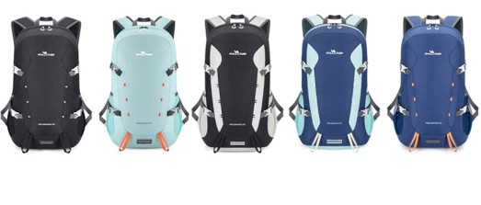
JY-147
Travel Camping Waterproof Backpack
TypeSoftback Pattern TypeOther Closure Typezipper
InteriorComputer Interlayer Handle/Strap TypeSoft Handle Lining MaterialPolyester StyleFashion
Capacity36-55 Litre Packaging and delivery Selling Units:Single item
Single package size:29X10X50 cm Single gross weight:0.500 kg

JY-149
Product nameGas Tank Storage Bag MaterialPolyester / Nylon / Canvas / Leather / EVA / Neoprene etc.
Gas Stove Canister Pot Carry Bag
LogoSilk-screen /Embroidery /Debossed / Woven Label etc.
ColorsCustomized Pantone Color SizeCustomized Size
Sample time7 workdays MOQ1000pcs
PackingPoly bag (OEM packaging) ApplicationDutch Oven / Storage / BBQ / Camping etc.
KeywordsBurner Storage Bag

JY-150
Insulated picnic Bag
ColorGray
Package InformationBag Capacity24 Liters Product Dimensions
13.78"D x 11.02"W x 11.02"H
Special FeatureThermal Insulated PatternSolid
Insulation Materialpeva Chamber Height11 Inches Large Capacity: Dimensions -
13.8" ( 35cm ) × 11" ( 28cm ) × 11" ( 28cm ).
Outdoor fishing bag

JY-151
Large (14.96*10.24* 4.33inch) Standard (11.8*8.3*4.0inch)
Care instructions Hand wash only

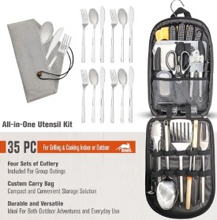
JY-148
Outdoor camping cookware storage Bag
Color Single MaterialStainless Steel Number of Pieces 35

JY-152
Item Weight2.6 Pounds
Waterproof Dry backpack Duffel Bag
Item Dimensions 10"D x 21"W x 16"H Storage Volume2 Liters
Unit Count1 Count Number Of Pockets5
Apparel Closure TypeBuckle Outer Material1560D PVC
Material TypePolyvinyl Chloride (PVC) Shell TypeSoft Shell
Lining DescriptionVinyl

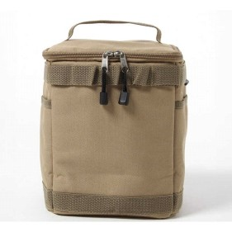
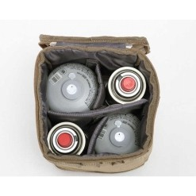
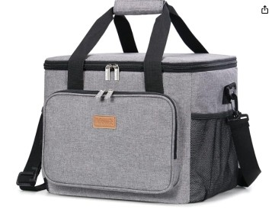
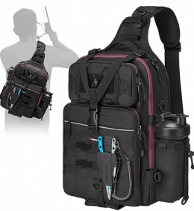
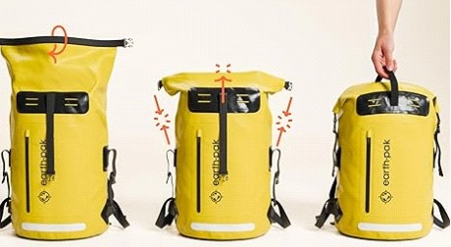

Molle Outdoor First Aid Pouch
Portable Outdoor Camping Tool bag

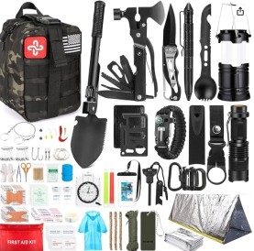
Insulated Folding camping Bag
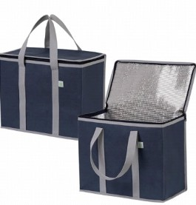

JY-153
MaterialNylon
Item Weight4.6 Pounds
Included Components250Pcs Survival Gear

JY-154
Fabric typeNon Woven
Measuring 15.7” W x 12.6” H x 8.7” D, our bags offer a large carrying capacity,
capable of holding 7.3 gallons or 40 cans. Easily accommodate multiple orders for delivery, camping trips, tailgating, and more.

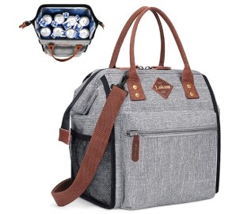
JY-155
Outdoor Aluminum Foil Cooler Bag
Recommended Uses For ProductOffice, Picnic, Hiking
Age Range (Description)Adult Special FeatureLeak-proof, Insulated Capacity330 Milliliters
ThemeGrey
Product Dimensions12"D x 6"W x 12"H PatternSolid
Large lunch bag has a main compartment(10.5"x6"x12"),
a big front zipper pocket (8"x7"x1.5"),
a back pocket (9.5"x6.5") and 2 side mesh pockets. Top handles and adjustable & removable shoulder strap(25"-50") design for easy carry.

JY-157
MaterialStainless Steel, various plastics, woven cotton
Handle MaterialStainless Steel Included ComponentsSpatula Is Dishwasher SafeYes

JY-158
Unisex Waterproof Backpack
Item Weight2 Pounds
Item Dimensions 5.9"D x 11.8"W x 16.5"H Storage Volume20 Liters
Outer MaterialPolyester Material TypeNylon Shell TypeSoft Shell Lining DescriptionNylon
Product Care InstructionsMachine Wash Apparel Closure TypeZipper
Water Resistance LevelWaterproof Pocket DescriptionUtility Pocket RAY,
Stash Pocket Compatible Device Size Maximum
15.6 InchesStrap TypeShoulder Strap
Nylon Waterproof Outdoor Duffle Bag

JY-159
Item Weight1.2 Pounds
Item Dimensions 28.3"L x 16.5"W x 12.9"H Capacity65 Liters
Handle TypeWeb Handle
Water Resistance LevelWaterproof Strap TypeRemovable, Adjustable

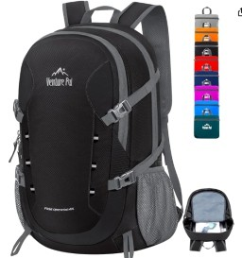
JY-156
Waterproof Hiking Foldable Backpack
Item Weight0.7 Pounds
Item Dimensions 8.7"D x 12.5"W x 20.1"H Storage Volume40 Liters
Unit Count1 Count Number Of Pockets4
Apparel Closure TypeZipper
Water Resistance LevelWater Resistant Pocket DescriptionSlit Pocket
Strap TypeShoulder Strap Embellishment FeatureBuckle9

JY-160
Material TypeNylon Shell TypeSoft Shell Lining DescriptionNylon
Outdoor Hiking Backpack
Product Care InstructionsHand Wash Only Item Dimensions 15"D x 8"W x 21"H Storage Volume60 Liters
Apparel Closure TypeZipper
Water Resistance LevelWater Resistant Pocket DescriptionUtility Pocket Compatible Device Size Maximum17 Inches Strap TypeAdjustable
Embellishment FeatureCord

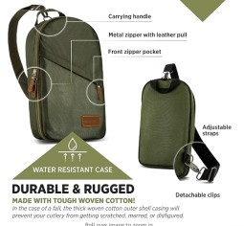
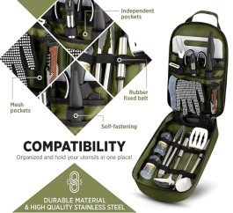
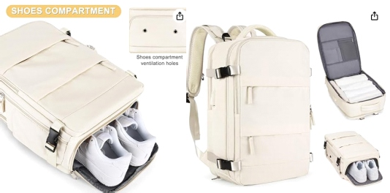
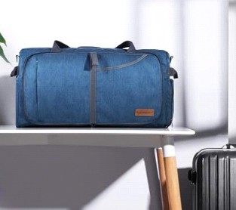
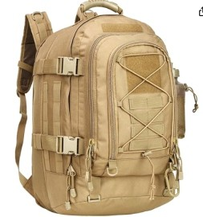

Portable 3-in-1 Camping Hammock
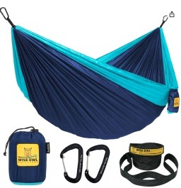

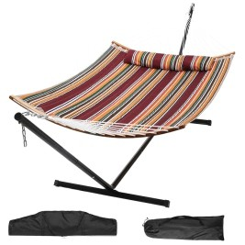
Portable Nylon Camping Hammock

JY-161
Seating Capacity2.0 ColorBlack & Grey Material TypeNylon Measurements
Item Weight28.5 Ounces
Maximum Weight Recommendation 500 Pounds

JY-162
ColorCustomized Color UsageYard,Garden MaterialFabric
Weight capacity204KGS(450BLS) Sample lead time5-7 Days FeatureDurable
LogoHR
Packaging and delivery Selling Units:Single item
Single package size:142.0X15.0X15.0 cm Single gross weight:10.000 kg

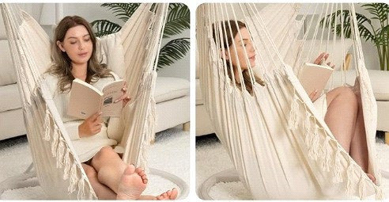
JY-163
Sewing Hanging Parachute Hammock
Product Dimensions53"L x 38"W Folded Size39 x 9 x 6 inches
Kindly don not exceed the weight more than 500 pounds.
ColorBeige

JY-165
Material: Parachute nylon fabric Weight Capacity: 500lb ( 226.80kg ) Size: 300 x 200cm ( 118''L x 78''W )
Lightweight Camping Hammock
Weight: 35 ounces Hammock Stap: 10 Feet long
Carabiner: 8x80mm, Maximum tension 300kg

JY-166
Hiking Nylon Hammock Bed
Warranty DescriptionLifetime warranty. ColorUsa Green Bundle
Included Components1*Hammock Rain Fly(120in*115in), 1*Hammock with Net (55in*106in), 2*10ft Hammock Tree Straps+2*Carabiners, 8*Reflective Guy Lines, 4*Tent Stakes+Waterproof Carry Bag Size55"W*106"L

JY-167
Portable Outdoor Camping Hammock
MaterialNylon Applicable PeopleAdult Length260*140cm Seating capacity2 Other attributes
Product nameMosquito Net Hammock MaterialNylon 210T (Parachute Cloth) ColorAs picture show or customized LogoCustomized Logo Availabled FeatureLightweight, Portable, Breathable Weight capacity300kg
Weight800g

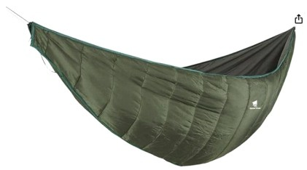
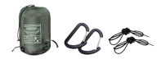
JY-164
Travel Camping Hammock
Soft & Durable Material
The 3 - 4 Seasons HAMMOCK QUILT is ideal for temperatures from 41°F to 68°F ;
Waterproof Shell: 20 D 380 T nylon plaid fabric Soft Lining: 300 T polyester pongee
Warm Filling: Imitation silk floss

JY-168
Other attributes
Backpacking Travel Camping Hammock
Product nameOutdoor Hammock UsageOutdoor Activity ApplicationCamping Hiking Travel Beach TypeStrength Hammock
Size82.7X27.6 INCH
Material Nylon Applicable People Adult Length 82.7 INCH

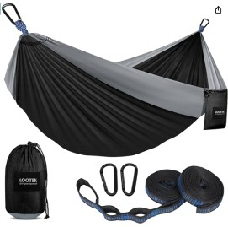
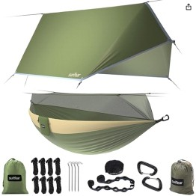
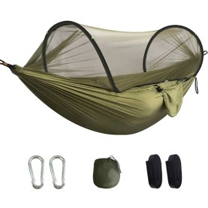
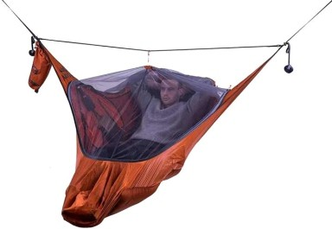

Outdoor Hunting Camping Hammock
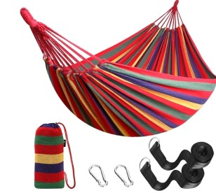

Portable Waterproof Camping Hammock
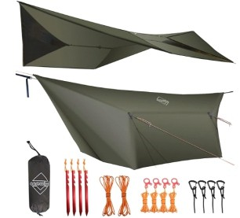

JY-169
Product Dimensions106"L x 59"W Max. Recommended Weight
250 kilograms
Color Red
Item Weight3.78 pounds

JY-170
ColorOd Green-12' Rectangular MaterialSilnyon
Water Resistance LevelWaterproof Item Weight2.2 Pounds
Recommended Uses For ProductCamping, Hiking
Product Dimensions143.7"L x 116.14"W Included Components4 aluminum tent stakes, 6*10ft light-reflective guyline,
4 guyline adjusters, Size12' Rectangular
Ultraviolet Light ProtectionTrue

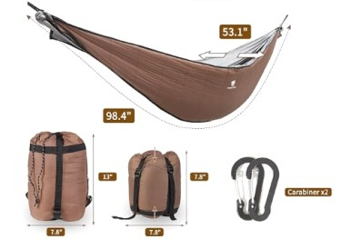
Jy171
Hiking Single Double Camping Hammock
20D 400T nylon plaid fabric300T polyester pongee Imitation silk floss

5'C-20°C/41°-68°F
1.87 lbs 98.4"x53.1"(Lx W)
Waterproof Shell: 400T nylon plaid fabric Soft Lining: 300 T polyester pongee Warm Filling: Imitation silk floss

JY-173
ColorDark Green
Hiking Hanging hammock
Product Dimensions90.5"L x 31.5"W Folded SizeApproximately
14.29 inches x 4.72 inches x 2.48 inches
(36.5 cm x 12 cm x 6.3 cm) Material
Nylon
Maximum Weight Recommendation 100 Kilograms
Item Weight 12 ounces
Seating Capacity 1.00
Travel Camping Sleeping Bag

JY-174
Item Package Dimensions
17.24 x 12.91 x 5.39 inches Package Weight2.24 Kilograms
Item Dimensions 86.6 x 31.5 x 3 inches Color4.4lb Blue
Manufactureroaskys Size31.5in x 86.6"

JY-175
Blue Toddler Camping Nap Bag
FeatureBreathable Available Quantity1000 TechnicsPrinted
Product TypeBaby Sleeping Bags SeasonFull-Season
Product NameSleeping Bag Baby KeywordsBaby Sleeper Bag FunctionSafe Sleep
UsageBaby Usage LogoAccept Customized Logo

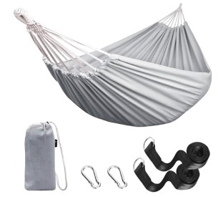
JY-172
Single person outdoor cloth hammock
Product Dimensions106"L x 59"W Folded Size[APX] 17 x 7 x 7 inches ColorGrey
Material Cotton
Maximum Weight Recommendation 300 Kilograms
Item Weight
1.7 Kilograms Seating Capacity

JY-176
SizeMedium
Portable TPU Inflatable Camping Mat
Special FeatureUltralight, Waterproof, Foldable ColorBlue
Product Dimensions75"L x 25"W x 3"Th Specific Uses For ProductSleeping Pad Included ComponentsUser Manual, Carry Bag Capacity600 Pounds
See less Material Nylon Weight Limit 600 Pounds

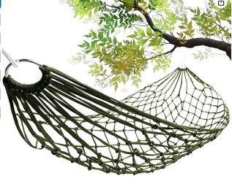
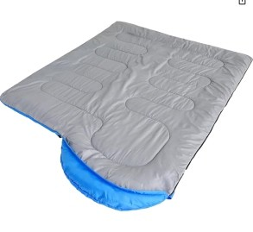
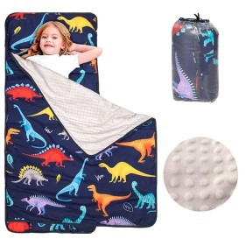
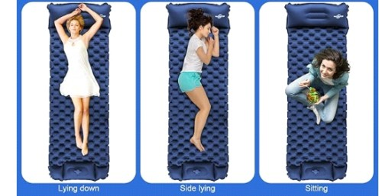

Adult 4-in-1 Outdoor Sleeping Bag
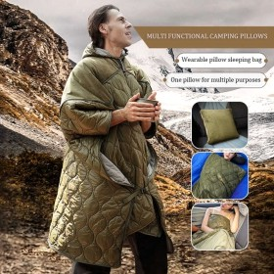

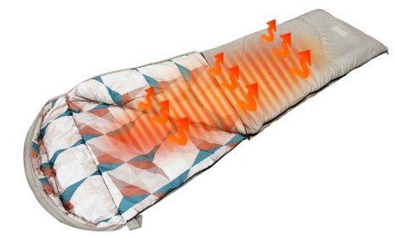
Adult Waterproof Winter Camping Bag

JY-177
Size190*135cm
MaterialPolyester, Polyester fabric, Cotton / Polyester, Polyester / Cotton, Nylon / Polyester FeatureWarm
Technicsmanual Stylemultifunctional Shapesquare
PatternOutdoor camping supplies UsePillow, cloak, blanket, sleeping bag is_customizedYes
Weight840g SeasonWinter MaterialPolyester Size190*135cm Folding size40*40cm

JY-178
MaterialPolyester
FeatureWaterproof \warm \breathable\ comfortable Usagecamping/hiking/traveling ColorGrey
Size190*58cm WEIGHT1.355kg
PackingPP Bag

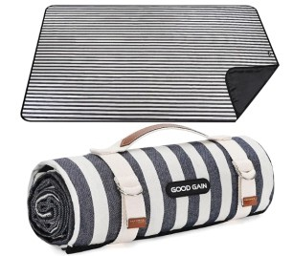
Y-179
Bohemian Waterproof Picnic Mat
Size78*57inch MaterialCotton Blend Weave TypeMachine Made Item Weight2.3 Pounds Pile HeightLow Pile ColorAegean Blue
Product Dimensions78"L x 57"W
Rug Form TypePicnic BlanketStyleCountry OccasionWedding, Picnic, Birthday, Camping Number of Pieces1
Water Resistance LevelWaterproof Age Range (Description)Toddler Item Weight2.3 pounds

JY-181
Age Range (Description)Adult SportCamping & Hiking, Hiking Product Dimensions7"L x 3"W Closure TypeDrawstring
Emergency Survival sleeping bag
Item Weight2.8 Ounces Outer MaterialMylar
Fabric TypeMylar, Reflective, Bivy Sack, Bivvy Sack
Size2 Sleeping Bags
Maximum Height Recommendation5.83 Feet Item Package Dimensions
6.77 x 5.51 x 2.68 inches Package Weight0.3 Kilograms
Item Dimensions LxWxH7 x 3 x 0.04 inches
Waterproof Camping Sleeping Bag

JY-182
FillingCotton, DUCK DOWN, GOOSE DOWN FabricNylon, Polyester, Cotton
TypeCold Weather Size220*80*50cm
Single/Double Sleeping BagSplicing Single Sleeping Bag

JY-183
durable constant temperature camping sleeping bag
FillingCotton FabricNylon TypeCold Weather Size193*137cm ColorOlive
MaterialNylon+ cotton filling Size76*54inch/193*137cm Weight0.86kg PackageStorage Bag

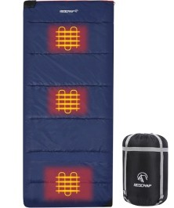
JY-180
Portable Heated Waterproof Sleeping Bag
Product Dimensions75"L x 33"W Closure TypeZipper
Item Weight4 Pounds
Outer MaterialPolyester, Cotton Fabric Type210T Polyester Plaid Fabric SizeMedium
Item Package Dimensions
17.48 x 12.8 x 7.8 inches Package Weight3.17 Kilograms
Item Dimensions 75 x 33 x 3 inches Fill Material TypePolyester

JY-184
ColorA1 Dark Grey/Regular(33''x87'') Product Dimensions87"L x 33"W Closure TypeZipper
Multifunction Connectable Sleeping bag
Item Weight2 Kilograms
Outer MaterialPolyester, Nylon Fabric TypePolyester Size33''X87''
Maximum Height Recommendation7.25 Feet Item Package Dimensions
16.34 x 11.65 x 5.87 inches Package Weight2.16 Kilograms
Item Dimensions LxWxH75 x 33 x 3 inches Fill Material TypePolyester

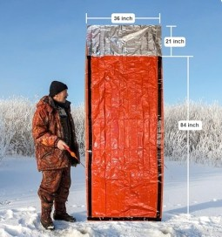
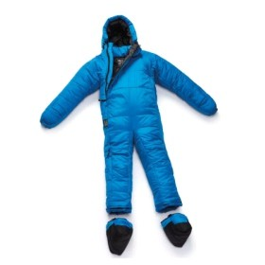
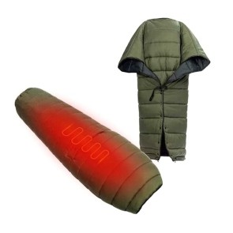
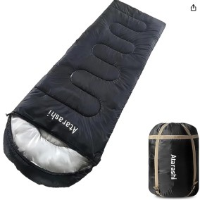

Beam Width Waterproof Boat Cover Yacht Cover

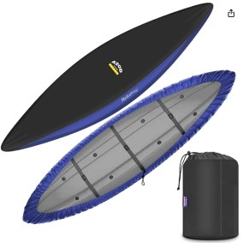

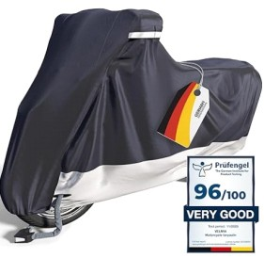
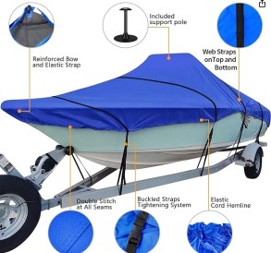
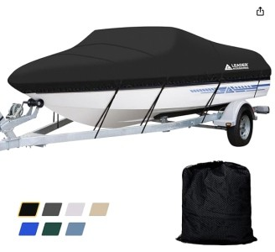
JY-185
Strap Design Waterproof Kayak Cover
Full scale protection boat cover
Waterproof 600D Motorcycle Shelter
Item Weight:22.9 pounds
Package Dimensions:17.3 x 15.6 x 10.1 inches
V-hull center console boats up to 22-24 ft long, with a beam width up to 116 inches and
a windshield height up to 30 inches

JY-186
Strap TypeClick close strap Item Package Dimensions
13.54 x 10.63 x 2.32 inches Package Weight0.95 Kilograms
Part NumberROSE-Canoe-PinBlue-L-hx Included Componentsstorage bag SizeSuitable for 12.3-13.5ft kayak

JY-187
Colorblack, silver
Water Resistance LevelWaterproof
Item dimensions 104.33 x 41.34 x 51.18 inches Coverageweather and impact protection for various motorcycles
ModelPremium Motorcycle Cover Item Weight4.4 pounds
Product Dimensions104.33 x 41.34 x 51.18 inches

JY-189
Area5.76㎡ FabricPE
Portable Waterproof Motorcycle Tent
Outside Tent Waterproof Index>3000 mm Bottom Waterproof Index2000-3000 Mm Building TypeConstruction Based on Need Product nameMotorcycle Shed
Bracket materialalloy steel MaterialPolyethylene PE Size1.8*1.8*1.8m/1.8*3*2m/2.4/2.4/2.4m Storage size104*44*15cm/113*52*20cm/ 103*43*15cm
Weight23kg/38kg/25kg
Aluminum Extensible Boat Canopy

JY-190
Item Type: Boat Sunshade Material: Aluminum Alloy Rod + 210D Coated Oxford Cloth Color: As Picture Shown Weight: Approx. 1980g

JY-191
Stainless Boat Bimini Top
Blue / Black. 54"-60"W / 61"-66"W / 67"-72"W /
73"-78"W / 79"-84"W /
85"-90"W / 91"-96"W /
97"-103"W.
MaterialPolyester ColorBlack
Closure TypeZipper PatternSolid
Item Package Dimensions
10.24 x 5.12 x 2.76 inches Package Weight13.76 Ounces Brand NameLeader Accessories Size85"-90"W

JY-188
Item Package Dimensions 17 x 12.2 x 7.6 inches Package Weight5.85 Kilograms
ColorBlack StyleSolution Dyed
SizeModel C: 16'-18.5'L Beam width up to 94''

JY-192
Size4.5" x 16" ColorNeon Green
Durable PVC Boat Rubber Fender
MaterialPolyvinyl Chloride Product Dimensions16"L x 4.5"W Item Weight2.3 Pounds

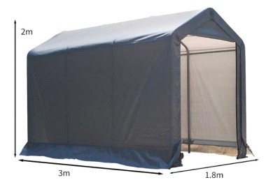
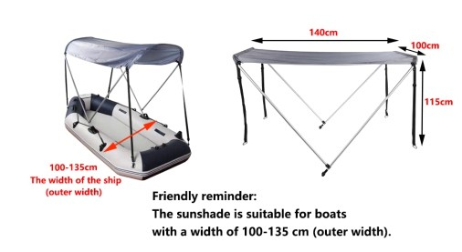
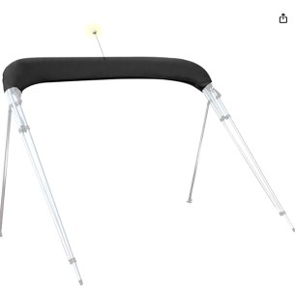
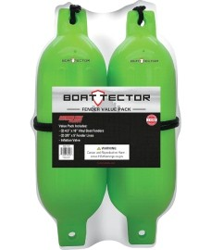

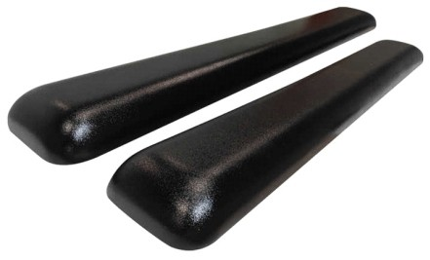
EVA Foam Marine Boat Fender

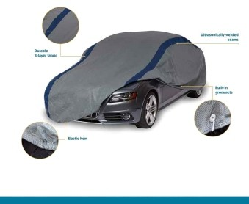
Foldable Retractable Car Shelter

JY-193
PartMarine EVA Foam Fender Product NameEVA Foam Boat Fender
MaterialOutside Polyurethane + Inner EVA Foam SizeCustomers' requirements
UsageBoat Protector PackingCarton Or Wooden Case CertificateISO9001
Warranty1 Year OEMAccetable

JY-194
Colortransparent Featuredustoff
Product NameFavorable Plastic car Cover UsageFour-season Protection
Design StyleDesign Style Place of OriginXiaMen, China UseOutdoor/Indoor

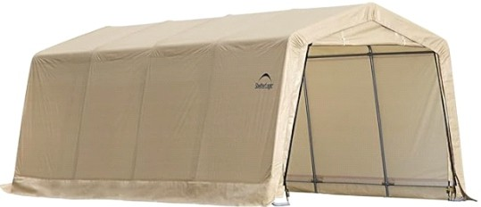
JY-195
All-Weather Car Shelter Canopy
MaterialPolyethlene ColorPeak
Item Weight61 Grams
Frame MaterialMetal, Wood, Alloy Steel Closure TypeZipper
Coverage10' x 20' x 8' Assembly RequiredYes
Item Package Dimensions 43.5 x 20.5 x 12.5 inches Package Weight144 Pounds
Item Dimensions 237.97 x 117.45 x 98.2 inches Suggested Usersunisex-adult
Style10' X 20' Autoshelter Size10' x 20' x 8'
Sport TypeCamping & Hiking

JY-197
Size3.8*2.7M
Automatic Remote Car Tent Umbrella
Materialhigh density 210D oxford cloth FunctionWaterproof,UV-proof
Product NameAutomatic Car umbrella Fabric Material210D Oxford cloth Frame MaterialFiberglass,PC
Open Size3.8*2.7M
Battery Type18650 Lithium battery Battery Capacity5000Mah Charging Current2A
Charging Voltage5V ColorNavy Blue,Silver Grey
Cat Dog Bed with Canopy

JY-198
Product Dimensions39.37"D x 23.62"W x 31.5"H MaterialMesh
ColorDog Canopy-Green StyleModern

JY-199
outdoor dog bed
Breed Recommendation Medium, Small Special Feature Environmentally Friendly, Orthopedic, Easy to Clean, Durable,
Non Skid Bottom Material Velvet, Cotton
Product Dimensions 30"L x 24"W x 9"Th

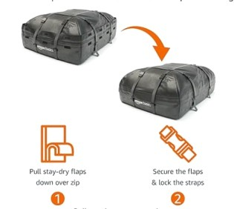
JY-196
Foldable Car Roof Cargo Bag
Water Resistance LevelWaterproof Mounting TypeRoof Mount,Strap Mount Item Volume424.8 Liters
Closure TypeZipper Shell TypeSoft
Item Weight6.31 pounds
Product Dimensions43.5 x 16.84 x 33.5 inches

JY-200
Breed RecommendationLarge
Portable Indoor & Outdoor Pet Hammockv
Special FeatureElevated,Cooling,Portable, Breathable,Lightweight,Weather Resistant, Travel,Non Skid Bottom
MaterialTeslin mesh, Metal
Product Dimensions49"L x 31.5"W x 8"Th

